Supplementary information for:

Anthropogenic and environmental drivers of vegetation change in southeastern Norway during the Holocene

ter Schure., A.T.M.a, Bajard, M.b,c, Loftsgarden, K.d, Høeg, H.d, Ballo, E. b,c, Bakke, J.e, Støren, E.e, Iversen, F.d, Kool, A.f, Brysting, A.K.a, Krüger, K.b,c , Boessenkool., S.a

a Centre for Ecological and Evolutionary Synthesis, Department of Biosciences, University of Oslo, Oslo, Norway

b Department of Geosciences, University of Oslo, Oslo, Norway

c Centre for Earth Evolution and Dynamics, University of Oslo, Oslo, Norway

d The Museum of Cultural History, University of Oslo, Oslo, Norway

e Department of Earth Science and Bjerknes Centre for Climate Research, University of Bergen, Bergen, Norway

f Natural History Museum, University of Oslo, Oslo, Norway

A.1. Geochemistry and radiocarbon ages 2

XRF geochemistry and chronology methods 2

Interpolation method 3

A.2. DNA filtering steps 4

A.3. DNA read counts per sample 5

A.4. DNA read counts and terrestrial biodiversity 6

A.5. Correlations between DNA reads and replicates 7

A.6. Temperature anomaly data 9

Interpolation method 10

A.7. Pollen stratigraphic plots 11

A.8. *Sed*aDNA stratigraphic plots 12

A.9. CONISS analysis 13

A.10. Non-Metric Multidimensional Scaling (NMDS) 14

A.11. Distance-based Redundancy Analysis (dbRDA) 15

A.12. Variation partitioning 19

A.13. Correlations between environmental terms 20

References 23

## A.1. Geochemistry and radiocarbon ages

### XRF geochemistry and chronology methods

Both cores were scanned with an ITRAX (XRF) core scanner from COX analytics at the EARTHLAB with a resolution of 200 µm for LJØ118 and 1000 µm for LJØ119. The surface of the cores was cleaned, smoothed and covered with an ultra-thin transparent film to avoid contamination and desiccation of the sediment. We used different settings for optimizing the sensitivity for the most interesting geochemical elements. These settings were adjusted to 35 kV and 30 mA for 10 s with a Mo tube to detect Ca, Ti, K, Si, Fe, Mn. To obtain matching resolutions of 1 mm and correlate the two cores, Ca, Ti, K, Si, Fe, Mn, Inc and Coh data of LJØ118 were averaged every 5 measures. The depth of the cores were correlated based on the variations in Ti, Fe and Mn and visual observation of the sediment using QAnalyseries 1.4.2 (Kotov and Paelike, 2018). As pollen and *sed*aDNA samples were taken from the LJØ119 core, we focus on the geochemical results for LJØ119 in this study (Fig. A.1).

The chronology of the sediment sequence is based on six AMS (accelerator mass spectrometer) radiocarbon dates from plant macrofossils from LJØ118 and realized by the Tandem Laboratory at Uppsala University (Table A.1). The 14C ages were calibrated using the IntCal20 calibration curve (Reimer et al., 2020). The age-depth model for the LJØ118 sequence was generated using R software (version 3.5.2; R Core Team, 2020) and the R code package ‘Bacon’ 2.4.3 (Blaauw and Christen, 2011). In the age model, the top of the core was set to the year of coring, i.e., 2018 CE. The chronology of LJØ119 was deduced from the LJØ118 age model.

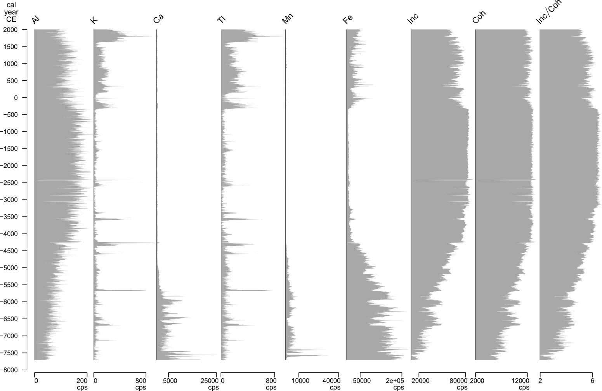

**Fig. A.1.** XRF measurements of Ca, Ti, K, Si, Fe, Mn, Inc and Coh in counts per seconds of the LJØ119 sediment core by an ITRAX core scanner from COX analytics.

**Table A.1.** Radiocarbon ages for the Lake Ljøgottjern sediment sequence. The 14C ages were calibrated using the IntCal20 calibration curve (Reimer et al., 2020).

|  |  |  |  |  |  |  |  |  |  |  |  |  |
| --- | --- | --- | --- | --- | --- | --- | --- | --- | --- | --- | --- | --- |
| **Lab number** | **Sample name** | **Core depth (cm)** | **Sample type** | **δ13C‰ V-PDB** | **14C age BP** | | | **Min. age (cal BP)** | **Max. age (cal BP)** | **Min. age (cal CE)** | **Max. age (cal CE)** | **Mean age**  **(cal CE)** |
| Ua-60967 | LJP118-I/IV-21,5-22cm | 70.25 | Leaf/bark | -23,6 | 431 | ± | 30 | 452 | 526 | 1498 | 1424 | 1461 |
| Ua-60968 | LJP118-I/IV-86-86,5 | 134.75 | Grass and some leaves | -27,9 | 1115 | ± | 32 | 956 | 1071 | 994 | 879 | 936.5 |
| Ua-60969 | LJP118-II/IV-12cm | 193 | Aquatic plant | -26,8 | 1623 | ± | 31 | 1406 | 1547 | 544 | 403 | 473.5 |
| Ua-60970 | LJP118-II/IV-69cm | 250 | Leaves/bark, seed | -24,8 | 1970 | ± | 31 | 1827 | 1949 | 123 | 1 | 62 |
| Ua-61898 | LJP118w-3av4 54-55cm | 375,5 | Pieces of leaves | -28,9 | 6455 | ± | 34 | 7309 | 7431 | -5359 | -5481 | -5420 |
| Ua-61899 | LJP118w-4av4 86,5-87cm | 527,75 | Bark | -26,8 | 8288 | ± | 35 | 9194 | 9424 | -7244 | -7474 | -7359 |

### Interpolation method

A generalised additive model (GAM) was used to smooth and interpolate values for generating geochemistry time series matching the resolution of the pollen and DNA datasets. In this process, the response variable for analysis (i.e. Ti and Inc/Coh ratio) was modelled as a function of time (cal year BP) using the *gam*-function of the *mgcv* package (version 1.8-35; Simpson, 2018; Wood, 2018) in R. We chose an adaptive smoother as Ti and Inc/Coh ratio series include periods of rapid change and periods of more gradual change. Settings for *k* varied to find the best model fit, evaluated with *gam.check.* We obtained interpolated values using the *predict.gam*-function.

## A.2. DNA filtering steps

**Table A.2.** Number of sequence reads and unique sequences remaining after each filtering step for the two sequencing pools. We processed the *sed*aDNA sequence data using the OBITools package (<http://metabarcoding.org/obitools/doc/index.html>; Boyer et al., 2016) and filtered the identified sequences in R (version 3.5.2; R Core Team, 2020).

|  |  |  |  |  |  |  |
| --- | --- | --- | --- | --- | --- | --- |
| **Filtering steps** | **Program** |  | ***Sequencing pool 1*** | | ***Sequencing pool 2*** | |
| **Target group (reference database)** | **Total reads** | **Unique sequences** | **Total reads** | **Unique sequences** |
| Raw reads |  |  | 220 591 834 |  | 64 492 511 |  |
| Pairwise alignment | *Illumina-*  *pairedend* |  | 220 591 834 |  | 64 492 511 |  |
| Assignment to samples | *ngsfilter* | plants  mammals | 51 781 661  103 795 998 |  | 31 320 055  23 091 660 |  |
| Removal of reads with count =1 & < 8 bp length & merging identical reads | *obigrep & obiuniq* | plants  mammals | 50 438 161  87 674 496 | 230 810  647 930 | 30 972 513  15 492 318 | 97 833  134 593 |
| Matching the reference database | *ecotag & obigrep* | plants (arctborbryo)  plants (embl)  mammals (embl) | 50 438 161  50 433 435  87 674 496 | 230 810  229 905  647 930 | 30 972 513  30 964 838  15 492 318 | 97 833  96 985  134 593 |
| Identification & removal of PCR/sequencing errors | *obiclean* | plants (arct)  plants (embl)  mammals (embl) | 48 012 330  48 008 064  83 348 865 | 143 172  142 610  453 823 | 29 810 852  29 803 609  15 015 242 | 97 833  96 985  81 575 |
| Merging the plant results from the two reference databases | R | plants | 48 012 348 | 143 190 | 29 810 881 | 51 821 |
| Removal of sequences that are not identified to the target group or without family attribute | R | mammals | 28 543 298 | 59 527 | 2 099 879 | 1 370 |
| Removal of sequences with maximum abundance in negative controls | R | plants  mammals | 47 682 752  24 781 219 | 143 045  49 066 | 29 766 311  1 894 232 | 51 613  1 177 |
| Removal of sequences with < 100% match (plants) or 98% match (mammals) | R | plants  mammals | 23 993 421  24 531 589 | 652  551 | 10 681 977  1 886 507 | 577  116 |
| Removal of sequences with < 10 reads in a PCR repeat | R | plants  mammals | 23 983 890  24 530 641 | 358  156 | 10 674 392  1 886 380 | 347  32 |
| Removal of PCR repeats with < 100 reads in total | R | plants  mammals | 23 983 745  24 530 420 | 358  156 | 10 674 365  1 886 230 | 347  32 |
| Removal of sequences present in < 2 PCR repeats & sequences with mean read count > mean read count in blanks | R | plants  mammals | 23 751 263  23 025 817 | 223  122 | 10 633 638  1 846 149 | 232  23 |
| Merging the pools | R | plants  mammals | 34 300 780  24 871 966 | 274  139 | -  - | -  - |

## A.3. DNA read counts per sample

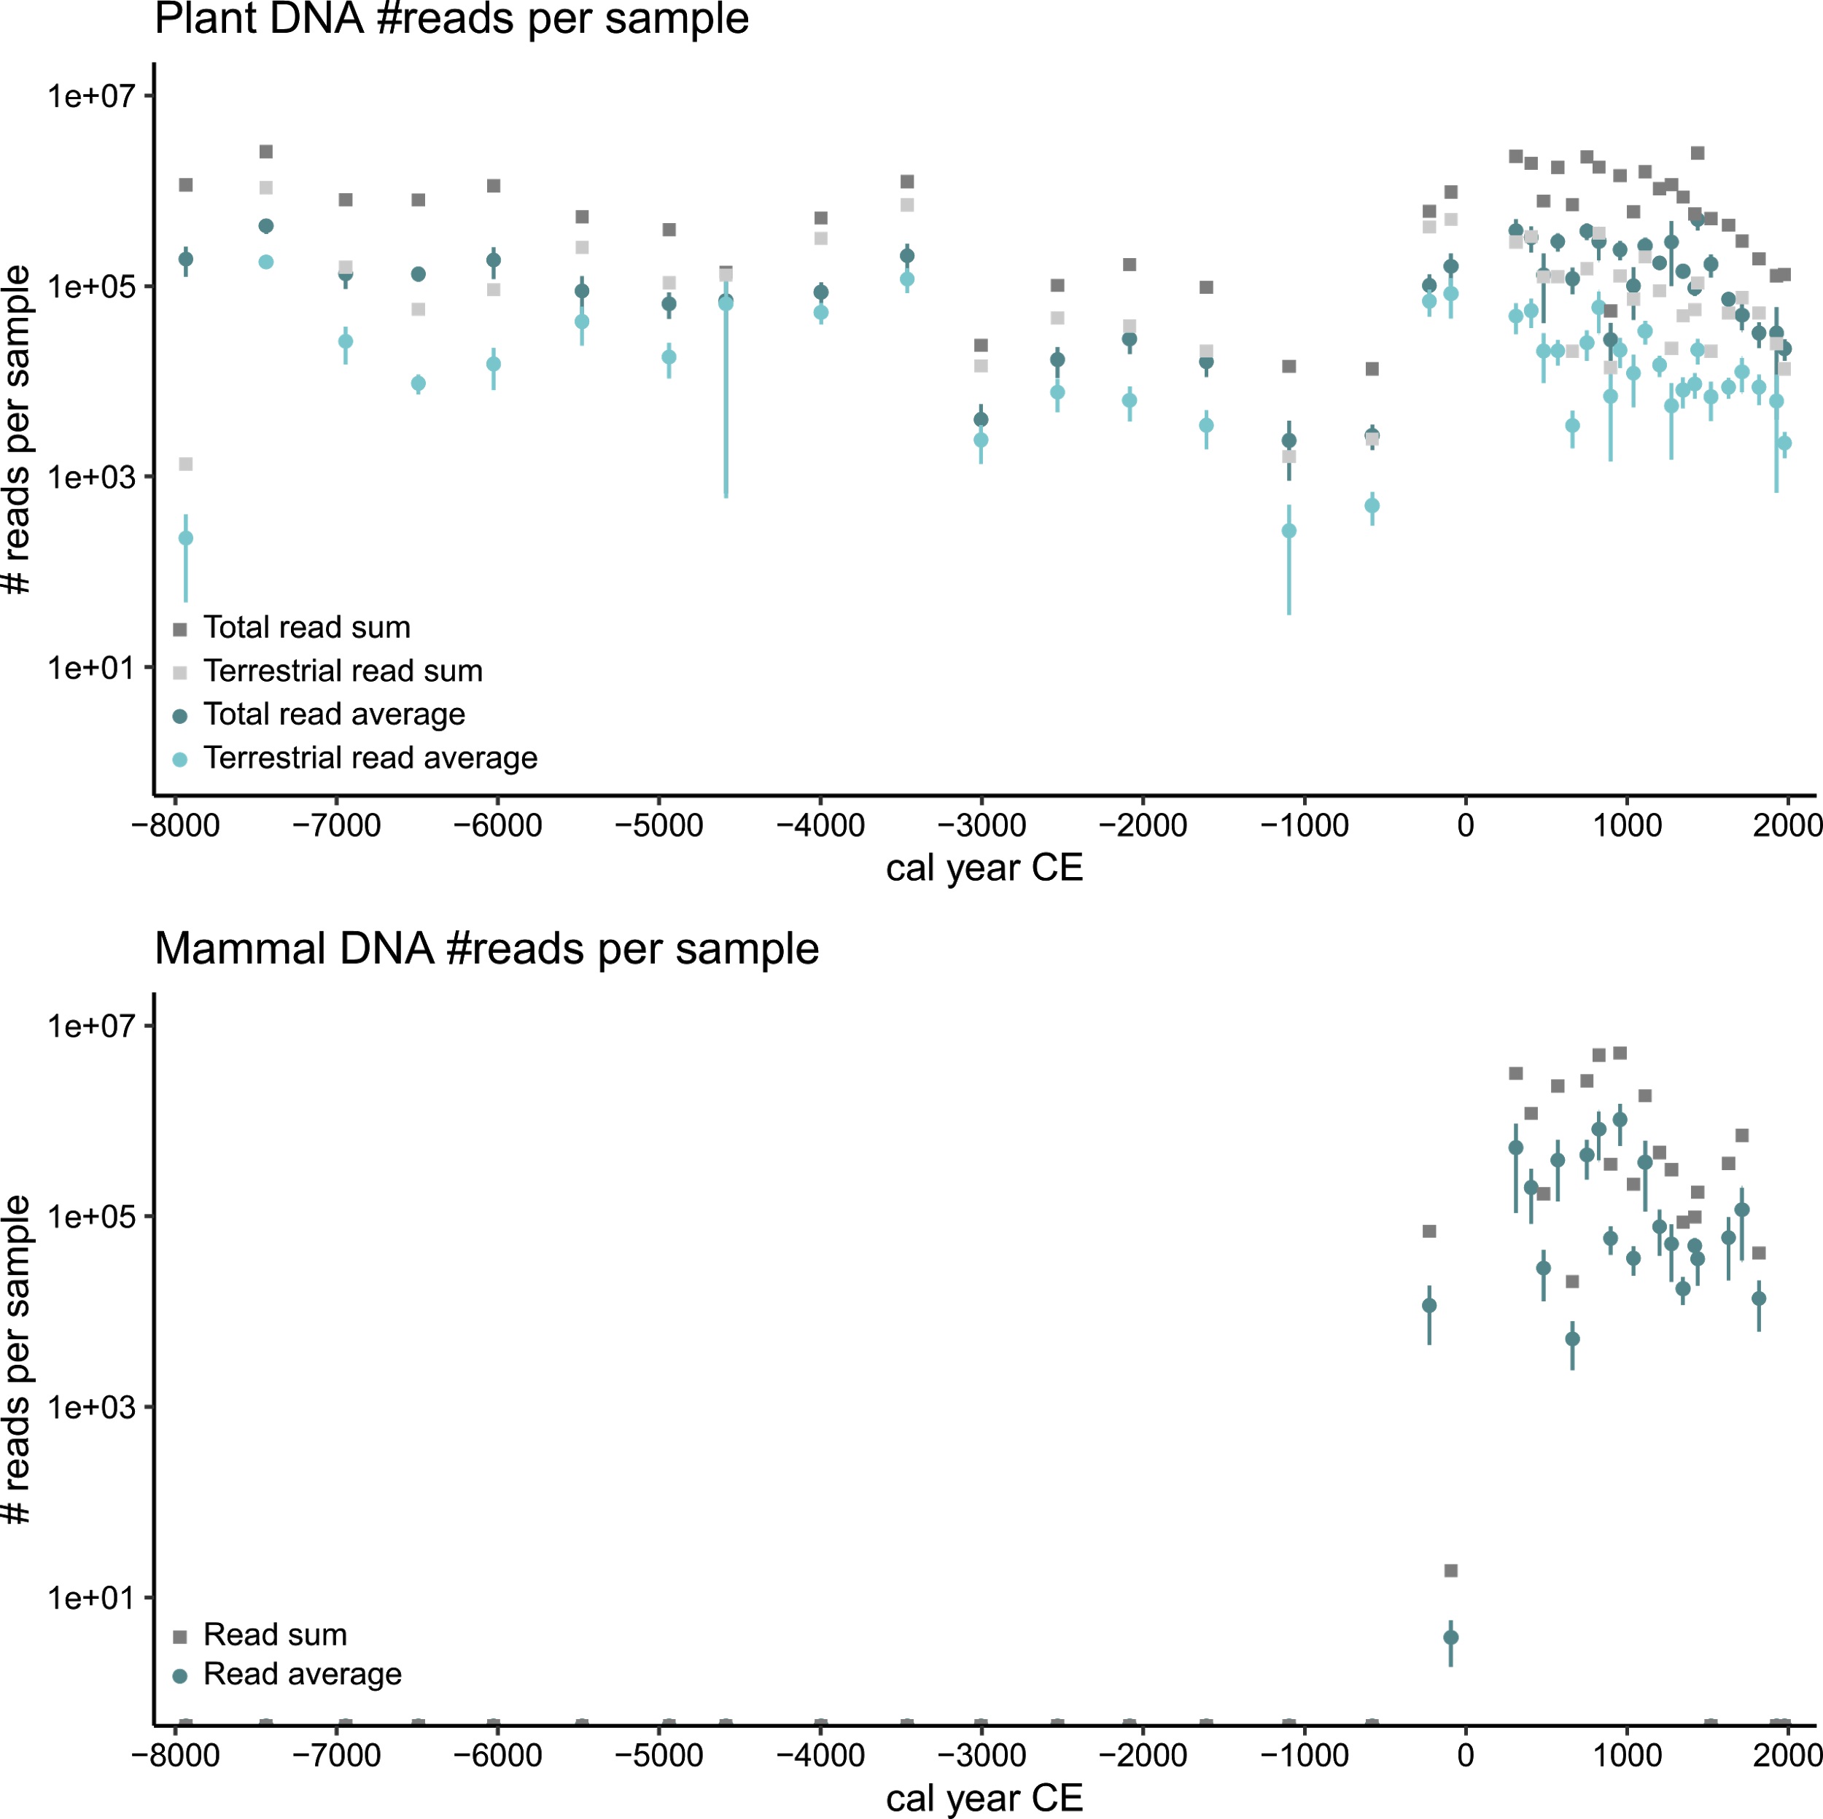

**Fig. A.3.** Summed and average read counts per sample for the total and the terrestrial plant *sed*aDNA (top) and mammal *sed*aDNA (bottom) datasets, with bars indicating the standard error from the mean.

## A.4. DNA read counts and terrestrial biodiversity

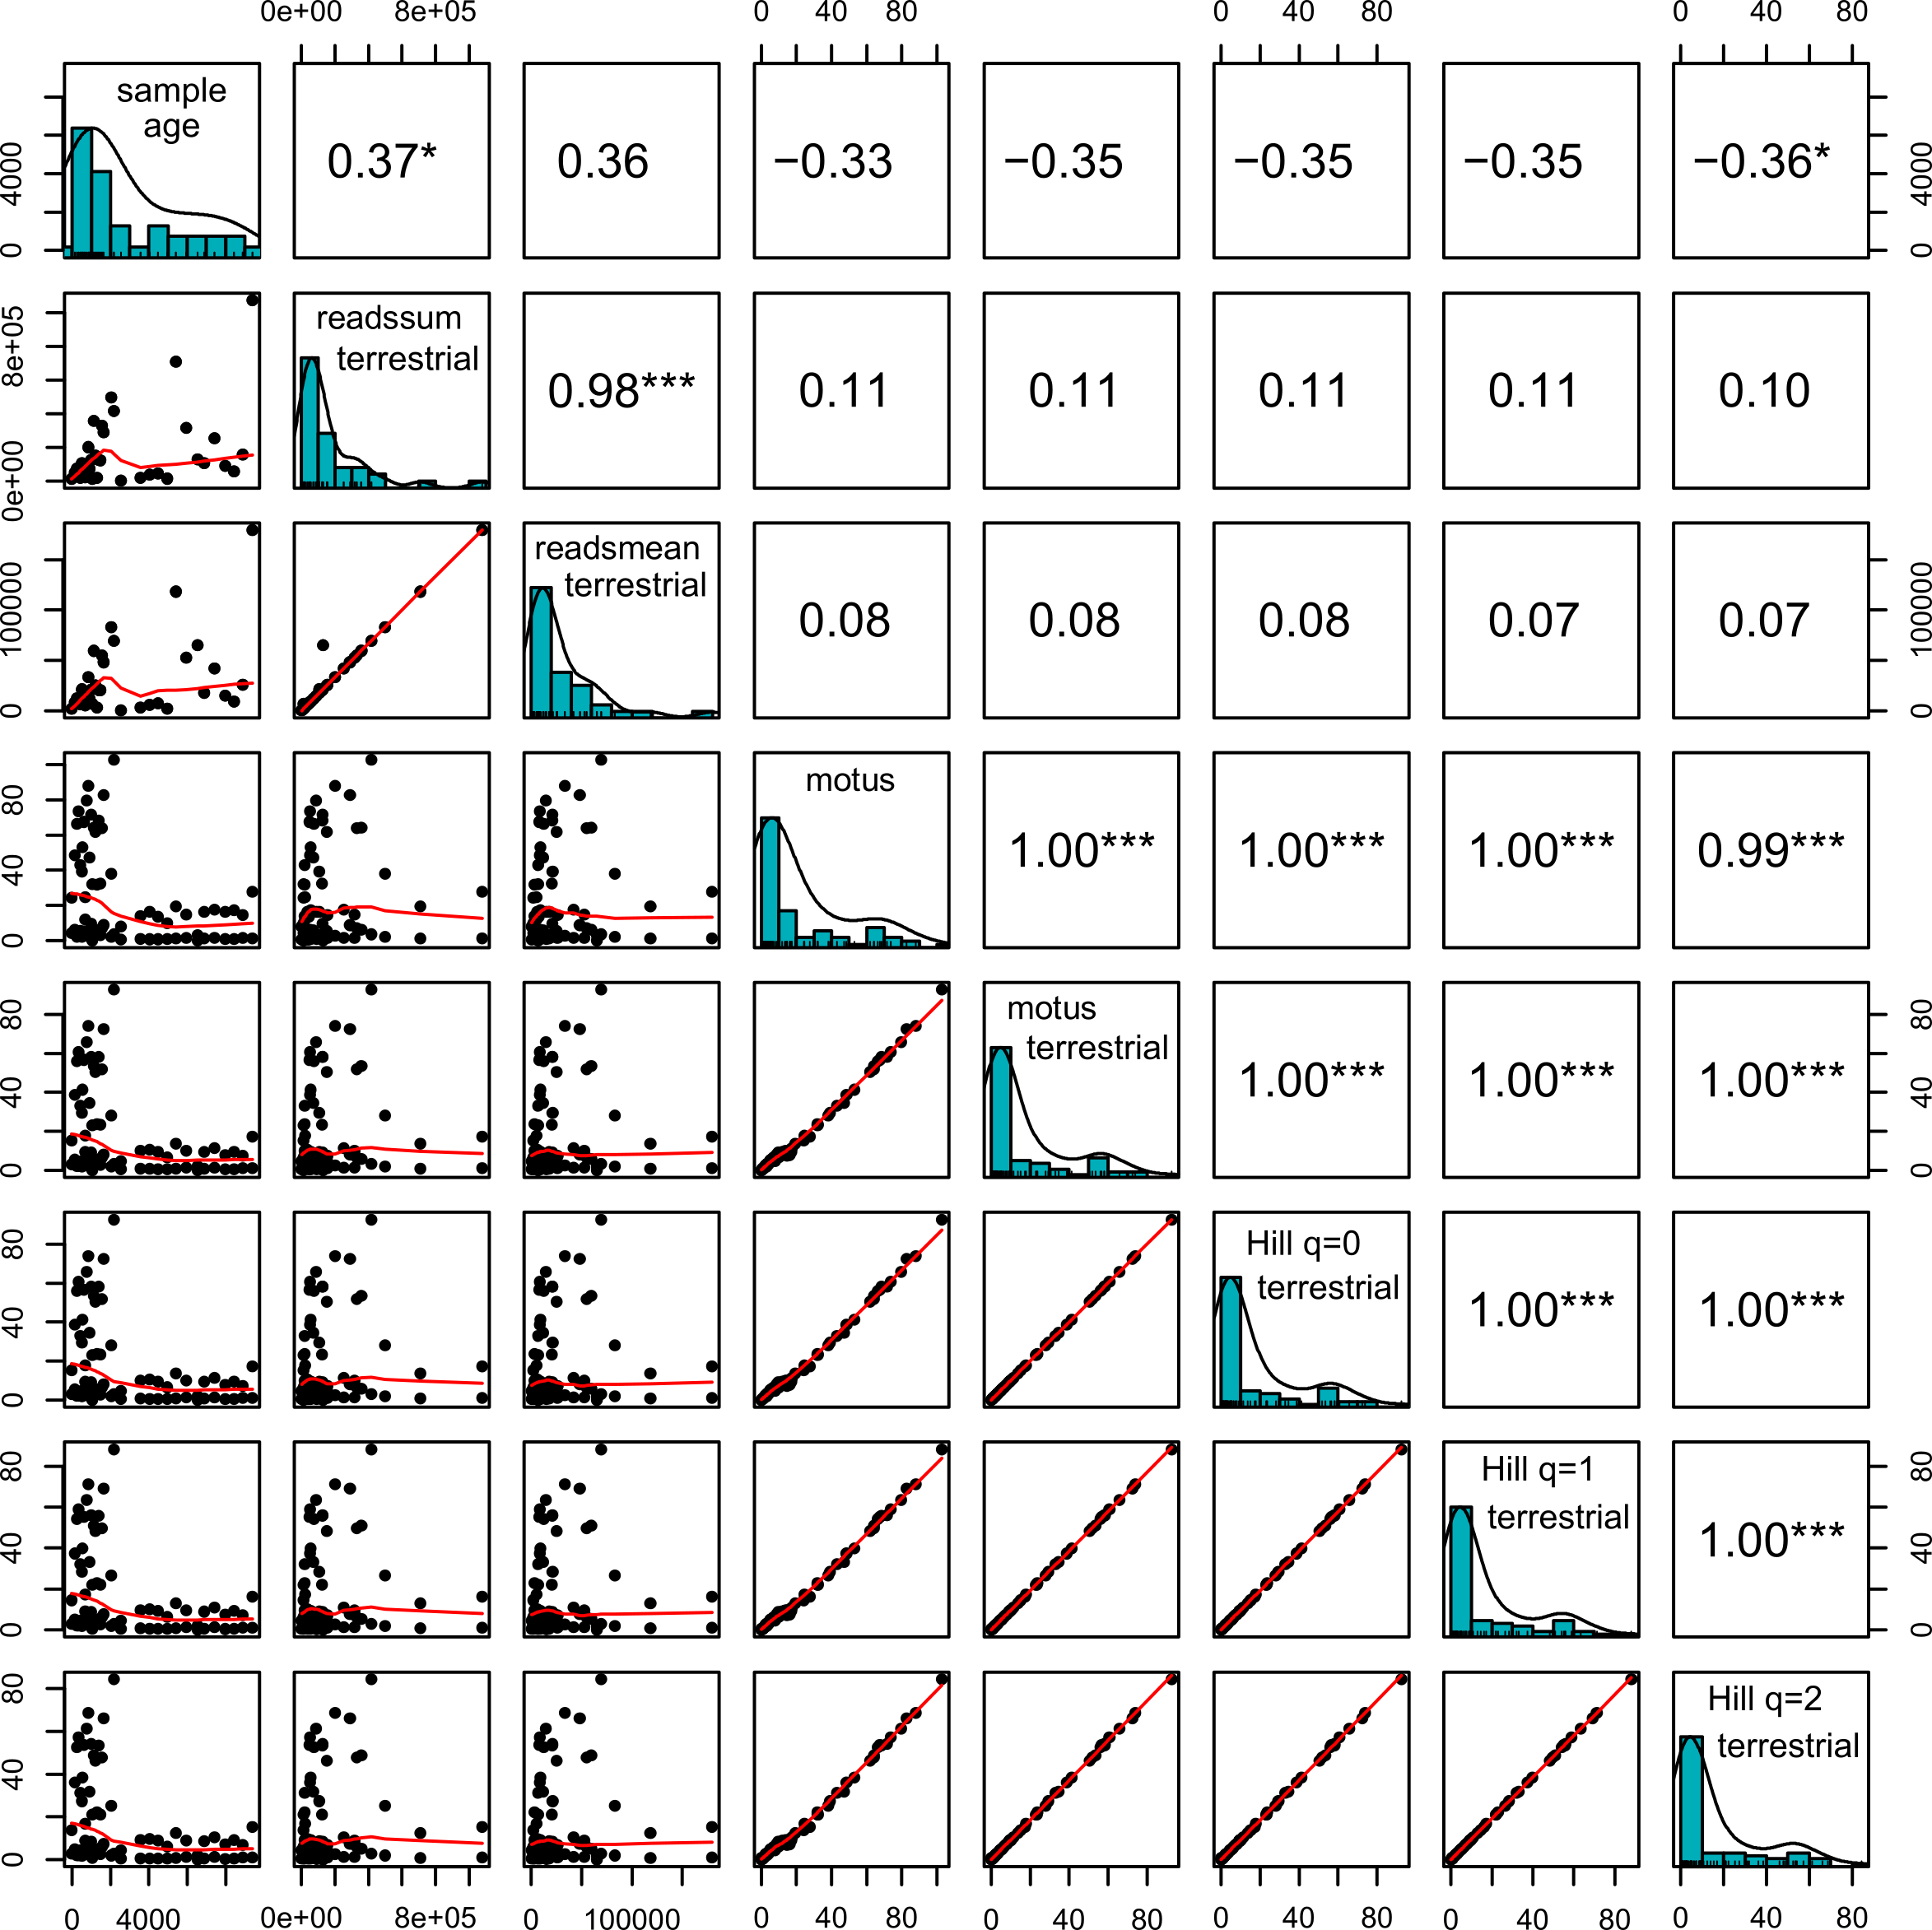

**Fig. A.4.** Spearman rank order correlations between terrestrial plant *sed*aDNA sample age (cal year BP), total number of sequence reads, average number of sequence reads, number of molecular operational taxonomic units (MOTUs), and Hill biodiversity numbers where q=0 corresponds to taxonomic richness, q=2 to Shannon diversity index, and q=2 to inverse Simpson index. P-values were adjusted with the Bonferroni method and significant correlations are indicated with *** *p-*value < 0.001, ** *p-*value < 0.01 and * *p-*value < 0.05.

## A.5. Correlations between DNA reads and replicates

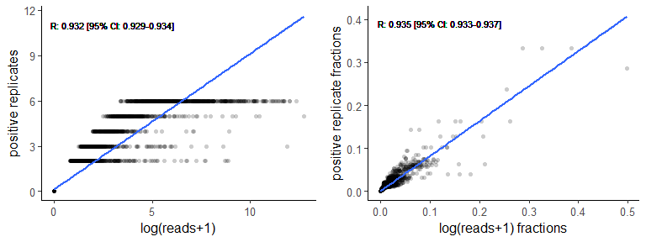

**Fig. A.5.** Pearson correlations between the log-transformed read counts and the number of positive replicates per plant molecular operational taxonomic unit (MOTU; r=0.932 [95% CI: 0.929-0.934]; left) and those standardized to sample fractions (r=0.935 [95% CI: 0.933-0.937]; right) of the total plant *sed*aDNA dataset(N=2185). Blue lines represent the calculated Pearson correlations.

Table A.5. Pearson correlations between the log-transformed read counts and positive replicates per molecular operational taxonomic unit (MOTU) in the plant *sed*aDNA dataset.

|  |  |  |  |  |  |  |  |  |  |  |  |  |  |  |
| --- | --- | --- | --- | --- | --- | --- | --- | --- | --- | --- | --- | --- | --- | --- |
| **MOTU** | **N** | **R** | ***P-*value** | | **MOTU** | **N** | **R** | ***P*-value** | | **MOTU** | **N** | **R** | ***P*-value** | |
| GH000072 | 10 | 0.945 | 4.31E-15 | *** | GH000015 | 9 | 0.991 | 1.17E-29 | *** | GH000116 | 1 | 1 | 0.00E+00 | *** |
| GH000073 | 2 | 1 | 5.50E-70 | *** | GH000016 | 1 | 1 | 0.00E+00 | *** | GH000115 | 1 | 1 | 0.00E+00 | *** |
| GH000166 | 15 | 0.948 | 1.18E-15 | *** | GH000018 | 17 | 0.973 | 5.49E-21 | *** | GH000188 | 2 | 0.997 | 1.84E-40 | *** |
| GH000087 | 8 | 0.980 | 2.14E-23 | *** | GH000020 | 4 | 0.998 | 3.21E-41 | *** | GH000195 | 4 | 0.971 | 1.86E-20 | *** |
| GH000085 | 16 | 0.985 | 6.71E-26 | *** | GH000021 | 4 | 0.986 | 2.21E-26 | *** | GH000124 | 4 | 0.995 | 1.03E-34 | *** |
| GH000044 | 1 | 1 | 0.00E+00 | *** | GH000023 | 3 | 0.995 | 1.47E-35 | *** | GH000121 | 1 | 1 | 0.00E+00 | *** |
| GH000277 | 2 | 0.998 | 1.75E-41 | *** | GH000024 | 1 | 1 | 0.00E+00 | *** | GH000122 | 24 | 0.928 | 5.93E-13 | *** |
| GH000278 | 4 | 0.972 | 1.18E-20 | *** | GH000027 | 23 | 0.946 | 2.25E-15 | *** | GH000125 | 1 | 1 | 0.00E+00 | *** |
| GH000017 | 10 | 0.996 | 1.82E-36 | *** | GH000028 | 1 | 1 | 0.00E+00 | *** | GH000126 | 20 | 0.965 | 9.58E-19 | *** |
| GH000019 | 6 | 0.996 | 5.99E-36 | *** | GH000029 | 9 | 0.959 | 1.73E-17 | *** | GH000127 | 2 | 1 | 1.17E-55 | *** |
| GH000038 | 2 | 0.998 | 1.02E-43 | *** | GH000030 | 26 | 0.915 | 1.07E-11 | *** | GH000128 | 1 | 1 | 0.00E+00 | *** |
| GH000146 | 2 | 0.993 | 5.81E-32 | *** | GH000031 | 7 | 0.994 | 1.62E-33 | *** | GH000163 | 1 | 1 | 0.00E+00 | *** |
| GH000147 | 24 | 0.951 | 3.80E-16 | *** | GH000032 | 17 | 0.929 | 4.27E-13 | *** | GH000051 | 20 | 0.933 | 1.24E-13 | *** |
| GH000264 | 22 | 0.953 | 1.64E-16 | *** | GH000033 | 3 | 0.992 | 1.13E-30 | *** | GH000158 | 1 | 1 | 0.00E+00 | *** |
| GH000229 | 12 | 0.978 | 9.30E-23 | *** | GH000034 | 7 | 0.983 | 9.25E-25 | *** | GH000050 | 2 | 0.998 | 1.10E-40 | *** |
| GH000162 | 22 | 0.967 | 2.07E-19 | *** | GH000007 | 15 | 0.981 | 1.34E-23 | *** | GH000052 | 12 | 0.989 | 2.51E-28 | *** |
| GH000206 | 1 | 1 | 0.00E+00 | *** | GH000035 | 3 | 0.977 | 2.42E-22 | *** | GH000046 | 2 | 0.993 | 4.07E-32 | *** |
| GH000205 | 12 | 0.977 | 2.18E-22 | *** | GH000036 | 24 | 0.936 | 6.25E-14 | *** | GH000047 | 19 | 0.941 | 1.40E-14 | *** |
| GH000091 | 5 | 0.909 | 3.80E-11 | *** | GH000025 | 1 | 1 | 0.00E+00 | *** | GH000159 | 23 | 0.983 | 1.09E-24 | *** |
| GH000090 | 3 | 0.987 | 1.13E-26 | *** | GH000189 | 1 | 1 | 0.00E+00 | *** | GH000049 | 14 | 0.981 | 6.92E-24 | *** |
| GH000257 | 2 | 0.995 | 2.44E-34 | *** | GH000069 | 4 | 0.998 | 7.88E-42 | *** | GH000059 | 23 | 0.921 | 2.94E-12 | *** |
| GH000089 | 1 | 1 | 0.00E+00 | *** | GH000071 | 4 | 0.997 | 9.07E-40 | *** | GH000045 | 18 | 0.935 | 7.19E-14 | *** |
| GH000088 | 1 | 1 | 0.00E+00 | *** | GH000130 | 1 | 1 | 0.00E+00 | *** | GH000157 | 19 | 0.982 | 1.96E-24 | *** |
| GH000057 | 7 | 0.985 | 8.07E-26 | *** | GH000132 | 1 | 1 | 0.00E+00 | *** | GH000104 | 1 | 1 | 0.00E+00 | *** |
| GH000259 | 4 | 0.992 | 1.26E-30 | *** | GH000129 | 1 | 1 | 0.00E+00 | *** | GH000111 | 2 | 1 | 6.19E-64 | *** |
| GH000155 | 5 | 0.995 | 5.52E-35 | *** | GH000131 | 2 | 0.998 | 1.46E-42 | *** | GH000095 | 5 | 1 | 4.52E-57 | *** |
| GH000156 | 3 | 0.993 | 1.19E-31 | *** | GH000055 | 1 | 1 | 0.00E+00 | *** | GH000102 | 8 | 0.958 | 3.04E-17 | *** |
| GH000053 | 28 | 0.967 | 2.65E-19 | *** | GH000169 | 13 | 0.979 | 6.66E-23 | *** | GH000103 | 10 | 0.99 | 7.69E-29 | *** |
| GH000056 | 7 | 0.990 | 2.11E-29 | *** | GH000039 | 2 | 0.989 | 2.01E-28 | *** | GH000170 | 11 | 0.986 | 2.20E-26 | *** |
| GH000150 | 38 | 0.798 | 5.18E-05 | *** | GH000040 | 1 | 1 | 0.00E+00 | *** | GH000105 | 1 | 1 | 0.00E+00 | *** |
| GH000151 | 38 | 0.544 | 1.00E+00 |  | GH000041 | 1 | 1 | 0.00E+00 | *** | GH000185 | 15 | 0.958 | 2.05E-17 | *** |
| GH000148 | 3 | 0.979 | 5.57E-23 | *** | GH000037 | 1 | 1 | 0.00E+00 | *** | GH000186 | 2 | 0.998 | 2.09E-41 | *** |
| GH000149 | 1 | 1 | 0.00E+00 | *** | GH000273 | 1 | 1 | 0.00E+00 | *** | GH000075 | 2 | 0.999 | 2.34E-53 | *** |
| GH000145 | 6 | 0.999 | 1.40E-52 | *** | GH000272 | 1 | 1 | 0.00E+00 | *** | GH000113 | 3 | 0.983 | 1.22E-24 | *** |
| GH000077 | 4 | 0.996 | 1.75E-36 | *** | GH000258 | 1 | 1 | 0.00E+00 | *** | GH000237 | 3 | 0.999 | 7.98E-48 | *** |
| GH000084 | 4 | 0.988 | 1.11E-27 | *** | GH000200 | 14 | 0.99 | 6.28E-29 | *** | GH000238 | 18 | 0.992 | 6.83E-31 | *** |
| GH000063 | 30 | 0.979 | 8.07E-23 | *** | GH000199 | 5 | 0.922 | 2.14E-12 | *** | GH000239 | 8 | 0.983 | 1.50E-24 | *** |
| GH000265 | 33 | 0.843 | 6.62E-07 | *** | GH000120 | 11 | 0.987 | 6.98E-27 | *** | GH000240 | 5 | 0.983 | 7.40E-34 | *** |
| GH000060 | 18 | 0.961 | 7.24E-18 | *** | GH000201 | 9 | 0.992 | 1.46E-30 | *** | GH000080 | 5 | 0.99 | 5.22E-29 | *** |
| GH000061 | 21 | 0.927 | 7.56E-13 | *** | GH000198 | 1 | 1 | 0.00E+00 | *** | GH000081 | 9 | 0.993 | 1.64E-31 | *** |
| GH000117 | 28 | 0.960 | 1.19E-17 | *** | GH000202 | 1 | 1 | 0.00E+00 | *** | GH000062 | 3 | 0.999 | 5.59E-52 | *** |
| GH000118 | 4 | 0.997 | 6.09E-38 | *** | GH000203 | 18 | 0.927 | 6.56E-13 | *** | GH000043 | 7 | 0.981 | 6.57E-24 | *** |
| GH000070 | 10 | 0.976 | 4.78E-22 | *** | GH000197 | 20 | 0.961 | 6.36E-18 | *** | GH000078 | 2 | 0.999 | 5.99E-45 | *** |
| GH000123 | 1 | 1 | 0.00E+00 | *** | GH000193 | 10 | 0.954 | 1.34E-16 | *** | GH000079 | 15 | 0.941 | 1.20E-14 | *** |
| GH000048 | 23 | 0.968 | 1.57E-19 | *** | GH000097 | 18 | 0.973 | 5.64E-21 | *** | GH000082 | 13 | 0.957 | 3.18E-17 | *** |
| GH000058 | 22 | 0.925 | 1.25E-12 | *** | GH000209 | 7 | 0.985 | 1.42E-25 | *** | GH000083 | 14 | 0.903 | 1.19E-10 | *** |
| GH000196 | 1 | 1 | 0.00E+00 | *** | GH000210 | 1 | 1 | 0.00E+00 | *** | GH000086 | 9 | 0.987 | 1.27E-26 | *** |
| GH000182 | 1 | 1 | 0.00E+00 | *** | GH000065 | 2 | 0.992 | 2.29E-31 | *** | GH000076 | 3 | 1 | 7.10E-56 | *** |
| GH000119 | 18 | 0.909 | 3.88E-11 | *** | GH000252 | 2 | 0.998 | 6.08E-41 | *** | GH000042 | 10 | 0.971 | 2.30E-20 | *** |
| GH000194 | 2 | 0.997 | 3.03E-38 | *** | GH000253 | 17 | 0.978 | 1.09E-22 | *** | GH000260 | 1 | 1 | 0.00E+00 | *** |
| GH000228 | 2 | 1 | 8.12E-55 | *** | GH000249 | 9 | 0.989 | 1.74E-28 | *** | GH000261 | 19 | 0.967 | 2.44E-19 | *** |
| GH000236 | 1 | 1 | 0.00E+00 | *** | GH000250 | 2 | 0.989 | 2.89E-28 | *** | GH000282 | 1 | 1 | 0.00E+00 | *** |
| GH000232 | 2 | 0.979 | 4.25E-23 | *** | GH000251 | 2 | 1 | 2.09E-88 | *** | GH000064 | 16 | 0.966 | 6.13E-19 | *** |
| GH000280 | 3 | 0.988 | 9.06E-28 | *** | GH000230 | 2 | 0.991 | 3.51E-30 | *** | GH000215 | 3 | 0.999 | 1.80E-50 | *** |
| GH000281 | 2 | 0.977 | 2.12E-22 | *** | GH000179 | 2 | 1 | 1.88E-62 | *** | GH000211 | 9 | 0.973 | 8.32E-21 | *** |
| GH000283 | 1 | 1 | 0.00E+00 | *** | GH000190 | 1 | 1 | 0.00E+00 | *** | GH000212 | 1 | 1 | 0.00E+00 | *** |
| GH000279 | 2 | 0.998 | 3.63E-44 | *** | GH000183 | 7 | 0.984 | 4.67E-25 | *** | GH000208 | 1 | 1 | 0.00E+00 | *** |
| GH000002 | 5 | 0.987 | 8.45E-27 | *** | GH000164 | 13 | 0.976 | 8.57E-22 | *** | GH000213 | 1 | 1 | 0.00E+00 | *** |
| GH000233 | 1 | 1 | 0.00E+00 | *** | GH000175 | 1 | 1 | 0.00E+00 | *** | GH000216 | 9 | 0.969 | 6.37E-20 | *** |
| GH000234 | 1 | 1 | 0.00E+00 | *** | GH000176 | 4 | 1 | 1.91E-60 | *** | GH000204 | 11 | 0.992 | 6.20E-31 | *** |
| GH000235 | 1 | 1 | 0.00E+00 | *** | GH000178 | 2 | 0.997 | 2.69E-38 | *** | GH000214 | 4 | 0.987 | 7.81E-27 | *** |
| GH000263 | 1 | 1 | 0.00E+00 | *** | GH000177 | 20 | 0.938 | 2.99E-14 | *** | GH000217 | 1 | 1 | 0.00E+00 | *** |
| GH000231 | 2 | 0.996 | 8.41E-37 | *** | GH000174 | 1 | 1 | 0.00E+00 | *** | GH000218 | 8 | 0.998 | 4.96E-43 | *** |
| GH000247 | 1 | 1 | 0.00E+00 | *** | GH000114 | 1 | 1 | 0.00E+00 | *** | GH000219 | 13 | 0.953 | 1.87E-16 | *** |
| GH000248 | 12 | 0.993 | 3.41E-32 | *** | GH000181 | 4 | 0.998 | 3.27E-43 | *** | GH000220 | 13 | 0.947 | 2.11E-15 | *** |
| GH000152 | 2 | 0.982 | 3.78E-24 | *** | GH000098 | 15 | 0.979 | 8.39E-23 | *** | GH000221 | 6 | 0.988 | 1.41E-27 | *** |
| GH000245 | 8 | 0.983 | 1.27E-24 | *** | GH000099 | 17 | 0.977 | 3.09E-22 | *** | GH000074 | 4 | 0.989 | 6.26E-28 | *** |
| GH000242 | 7 | 0.991 | 5.70E-30 | *** | GH000192 | 1 | 1 | 0.00E+00 | *** | GH000184 | 4 | 0.994 | 4.04E-33 | *** |
| GH000246 | 7 | 0.986 | 1.55E-26 | *** | GH000191 | 16 | 0.978 | 1.14E-22 | *** | GH000161 | 10 | 0.992 | 4.93E-31 | *** |
| GH000241 | 16 | 0.998 | 7.76E-43 | *** | GH000270 | 13 | 0.984 | 3.20E-25 | *** | GH000168 | 13 | 0.972 | 1.04E-20 | *** |
| GH000244 | 4 | 0.988 | 2.70E-27 | *** | GH000271 | 5 | 0.991 | 3.75E-30 | *** | GH000167 | 3 | 0.999 | 6.34E-50 | *** |
| GH000243 | 4 | 1 | 8.07E-56 | *** | GH000269 | 1 | 1 | 0.00E+00 | *** | GH000172 | 5 | 0.976 | 6.69E-22 | *** |
| GH000256 | 1 | 1 | 0.00E+00 | *** | GH000187 | 4 | 0.973 | 7.42E-21 | *** | GH000171 | 32 | 0.95 | 6.68E-16 | *** |
| GH000112 | 4 | 0.970 | 5.46E-20 | *** | GH000180 | 1 | 1 | 0.00E+00 | *** | GH000173 | 38 | 0.904 | 1.03E-10 | *** |
| GH000106 | 2 | 0.998 | 6.94E-43 | *** | GH000133 | 6 | 0.976 | 7.48E-22 | *** | GH000165 | 15 | 0.976 | 7.26E-22 | *** |
| GH000101 | 1 | 1 | 0.00E+00 | *** | GH000134 | 18 | 0.969 | 9.66E-20 | *** | GH000094 | 1 | 1 | 0.00E+00 | *** |
| GH000100 | 8 | 0.991 | 3.03E-30 | *** | GH000135 | 1 | 1 | 0.00E+00 | *** | GH000096 | 1 | 1 | 0.00E+00 | *** |
| GH000207 | 16 | 0.988 | 6.94E-28 | *** | GH000136 | 1 | 1 | 0.00E+00 | *** | GH000153 | 1 | 1 | 0.00E+00 | *** |
| GH000054 | 1 | 1 | 0.00E+00 | *** | GH000137 | 1 | 1 | 0.00E+00 | *** | GH000092 | 4 | 0.998 | 5.72E-41 | *** |
| GH000255 | 1 | 1 | 0.00E+00 | *** | GH000138 | 1 | 1 | 0.00E+00 | *** | GH000093 | 12 | 0.989 | 4.68E-28 | *** |
| GH000254 | 1 | 1 | 0.00E+00 | *** | GH000139 | 10 | 0.949 | 1.07E-15 | *** | GH000067 | 20 | 0.961 | 5.28E-18 | *** |
| GH000010 | 17 | 0.985 | 1.08E-25 | *** | GH000140 | 4 | 0.949 | 7.81E-16 | *** | GH000068 | 1 | 1 | 0.00E+00 | *** |
| GH000026 | 2 | 0.999 | 5.44E-45 | *** | GH000141 | 1 | 1 | 0.00E+00 | *** | GH000066 | 36 | 0.977 | 2.76E-22 | *** |
| GH000011 | 7 | 0.972 | 1.39E-20 | *** | GH000142 | 1 | 1 | 0.00E+00 | *** | GH000109 | 1 | 1 | 0.00E+00 | *** |
| GH000014 | 20 | 0.965 | 6.24E-19 | *** | GH000143 | 15 | 0.969 | 6.43E-20 | *** | GH000110 | 33 | 0.918 | 6.18E-12 | *** |
| GH000005 | 16 | 0.953 | 2.03E-16 | *** | GH000144 | 1 | 1 | 0.00E+00 | *** | GH000107 | 2 | 0.966 | 5.33E-19 | *** |
| GH000004 | 2 | 0.989 | 2.00E-28 | *** | GH000267 | 11 | 0.959 | 1.78E-17 | *** | GH000108 | 26 | 0.965 | 6.43E-19 | *** |
| GH000006 | 1 | 1 | 0.00E+00 | *** | GH000276 | 6 | 0.99 | 1.84E-29 | *** | GH000262 | 1 | 1 | 0.00E+00 | *** |
| GH000008 | 15 | 0.944 | 4.41E-15 | *** | GH000266 | 20 | 0.928 | 4.78E-13 | *** | GH000154 | 4 | 0.998 | 1.41E-42 | *** |
| GH000009 | 5 | 0.989 | 3.14E-28 | *** | GH000268 | 2 | 1 | 5.23E-68 | *** | GH000160 | 9 | 0.989 | 1.71E-28 | *** |
| GH000012 | 10 | 0.978 | 1.42E-22 | *** | GH000274 | 23 | 0.826 | 3.78E-06 | *** |  |  |  |  |  |
| GH000013 | 15 | 0.98 | 2.748E-24 | *** | GH000275 | 7 | 0.991 | 8.19E-30 | *** |  |  |  |  |  |

* *P*-value < .05

** *P*-value < .01

*** *P*-value < .001

## A.6. Temperature anomaly data

A

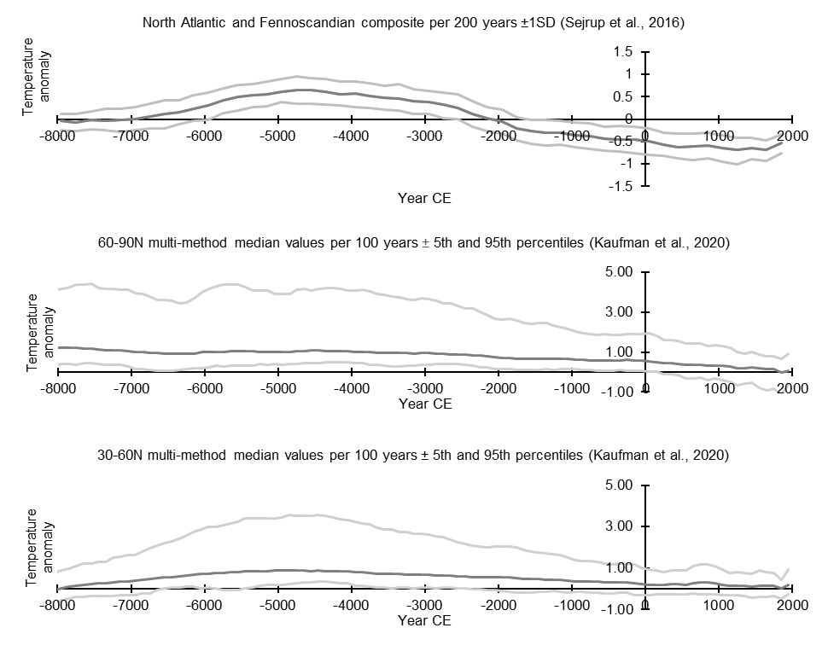



B

C

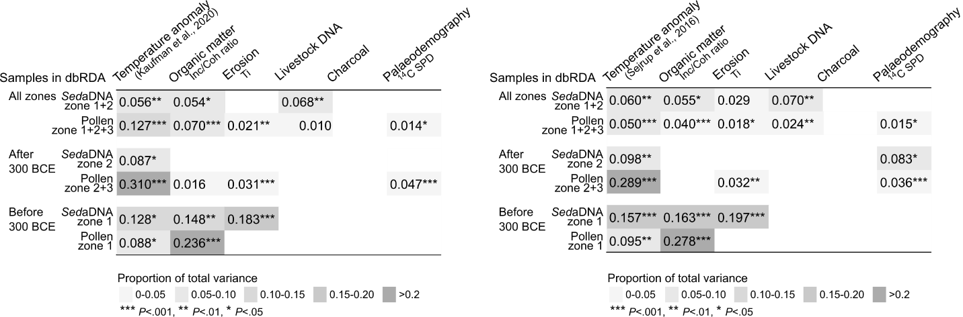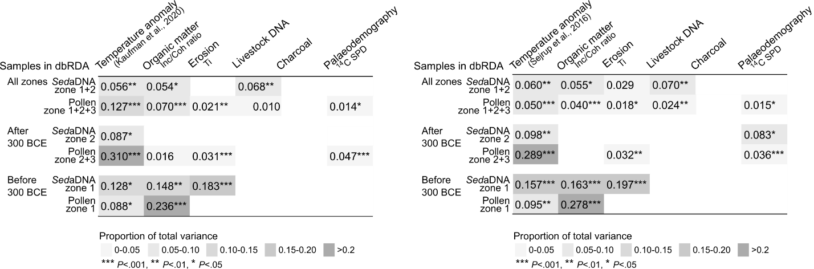

**Fig. A.6.** Surface temperature anomaly composites for A) the North Atlantic and Fennoscandia from Sejrup et al. (2016) and for B) the 60-90N northern hemisphere as presented by Kaufman et al. (2020). Grey lines around the temperature anomalies indicate the standard deviation (Sejrup et al., 2016) or the 5th and 95th percentiles (Kaufman et al., 2020). C) Stepwise distance-based redundance analyses (dbRDA; see Appendix A.11 for details) were performed separately for subsets of the pollen and *sed*aDNA data and using either the Sejrup et al. (2016; left) or the Kaufman et al. (2020; right) surface temperature anomaly composite. The conditional proportion of variance explained by the temperature anomaly composite from the Kaufman et al. (2020) publication for the dbRDA of all pollen samples is higher than that from the Sejrup et al. (2016) publication and some differences were found in the proportions of variance explained by the included environmental terms. However, the overall patterns of the dbRDA analyses using the different temperature anomaly composites are very similar.

### Interpolation method

General Additive Models (GAMs) allow flexible modelling of nonlinear relationships (Simpson, 2018), and were fitted to the surface temperature anomaly data using the *gam* function in the *mgcv* R package (version 1.8-35; Wood, 2018) to interpolate values and match the time resolutions of the pollen and DNA. In this process, the temperature anomaly was modelled as a function of time (cal year BP) with a thin‐plate regression spline using the *gam*-function in the *mgcv* package (Simpson, 2018; Wood, 2018) in R. Settings for *k* varied to find the best model fit, evaluated with *gam.check*, and we obtained interpolated values using the *predict.gam*-function.

## A.7. Pollen stratigraphic plots

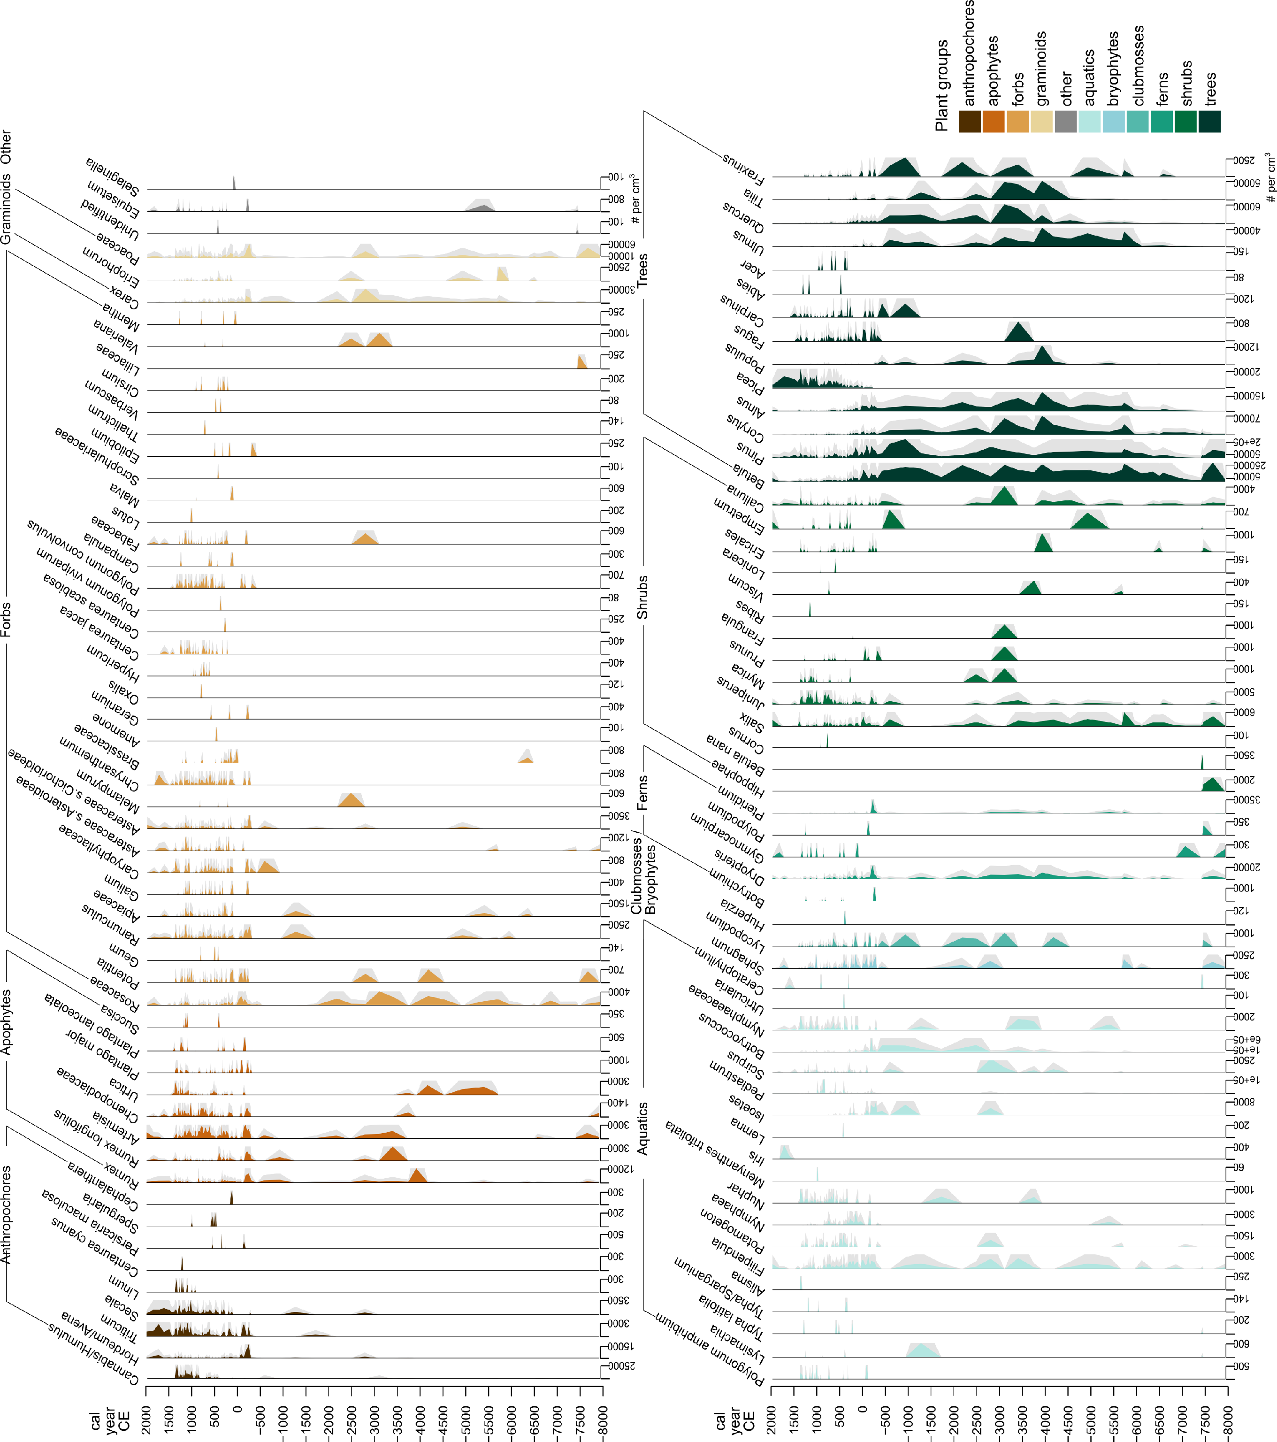

Fig. A.7. Pollen concentrations arranged and coloured by plant group. Grey areas indicate 3x exaggerated values.

## A.8. *Sed*aDNA stratigraphic plots

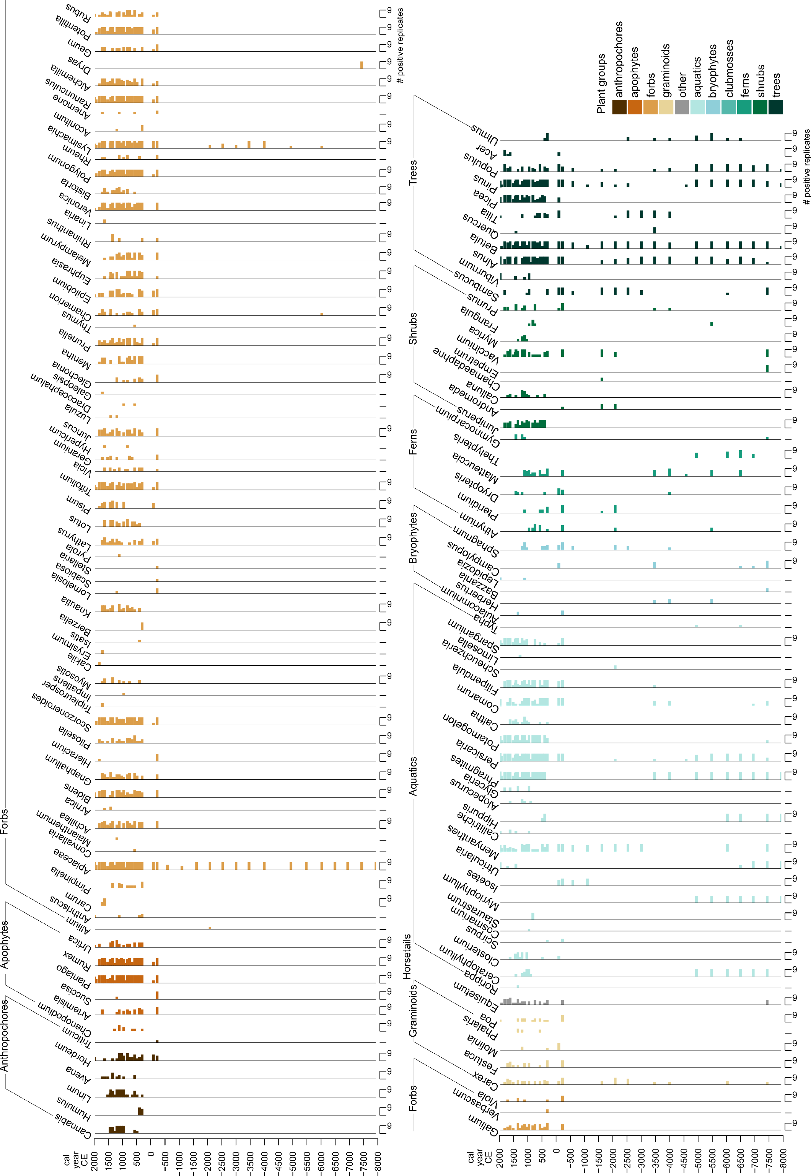

**Fig. A.8.** Number of plant *sed*aDNA positive PCR replicates per genus arranged and coloured by plant group.

## A.9. CONISS analysis

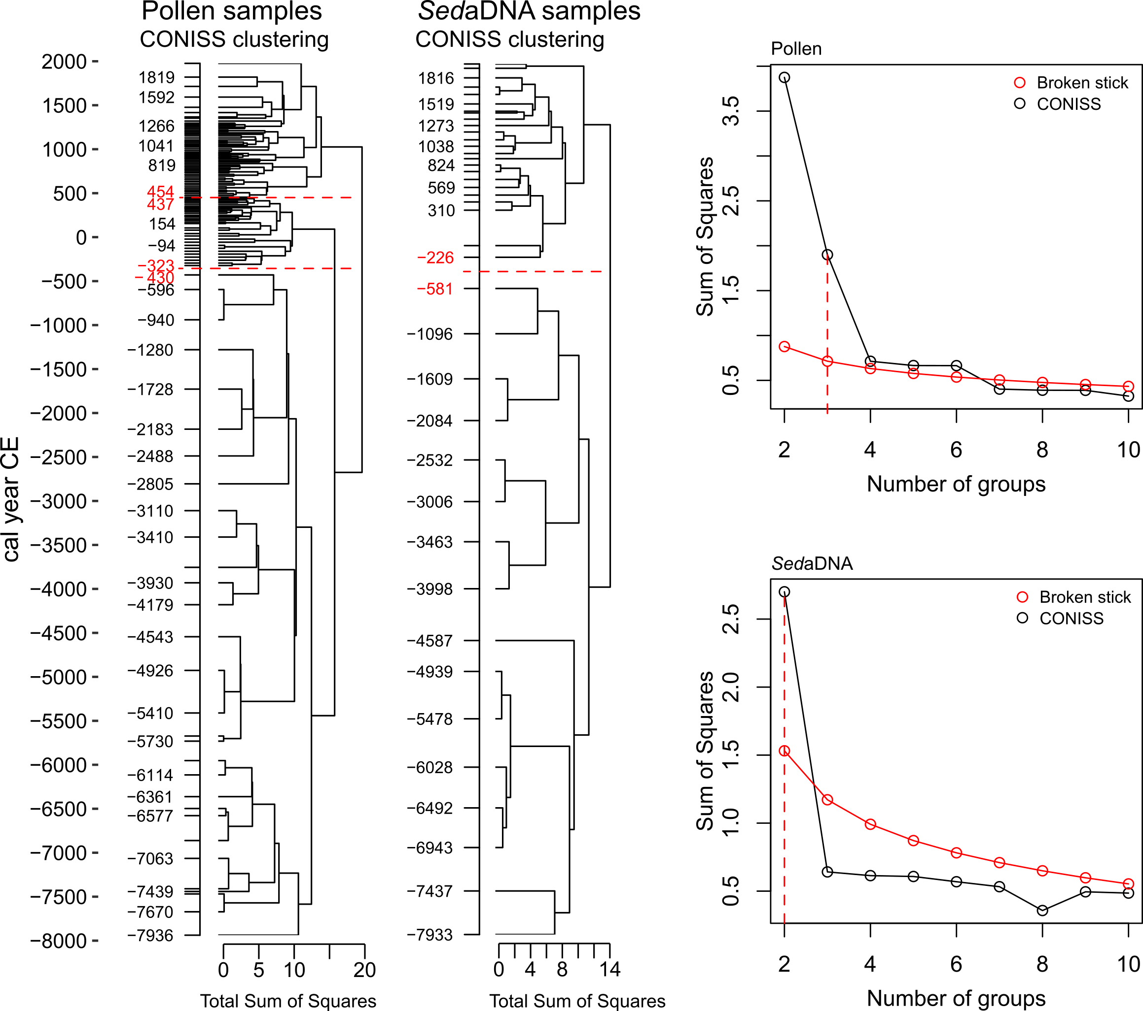

**Fig. A.9.** CONISS stratigraphically constrained cluster analysis based on the terrestrial vegetation data from pollen and *sed*aDNA analyses (left) and broken stick graphs showing the significant number of clusters found (right). Red dotted lines indicate significant clusters, and red-coloured cal year CE values indicate the age of the samples at the edges of the clusters. Pollen concentrations and *sed*aDNA positive replicate values were standardised to sample fractions using the “total” option in the *decostand*-function from the *vegan* package. We used *chclust-*function of the *rioja* package (Juggins and Juggins, 2020) with the CONISS algorithm posed by Grimm (1987) and Bray-Curtis distances. Based on the pollen data we found 6 significantly different groups, but as differences between the CONISS estimates and broken stick estimates were small for the additional 3 groups, we decided to focus only on the first 3 identified groups.

## A.10. Non-Metric Multidimensional Scaling (NMDS)

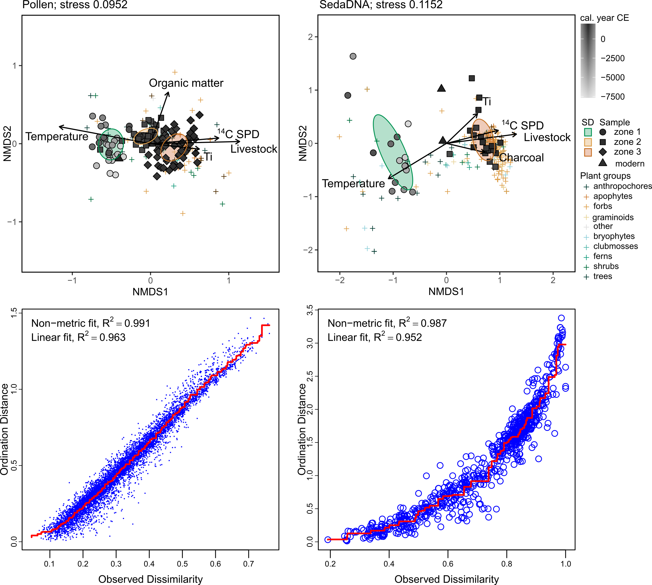

**Fig. A.10.** Non-metric multi-dimensional scaling ordinations of terrestrial plant pollen concentrations (left) and *sed*aDNA positive replicates (right) based on Bray-Curtis distances using the *metaMDS* function of the *vegan* package (Oksanen et al., 2020). Subdivision of samples into zones was done with CONISS analysis and we define modern samples as those from >1850 cal CE. Ellipses indicate the standard deviation of the mean for each zone. Plant taxa scores are indicated with ‘+’-signs and are coloured per plant group. Environmental terms were fitted to the ordination using the *envfit*-function with 999 permutations and only significant terms (*P* < .05) are shown here. Temperature corresponds to the temperature anomaly data published by Sejrup et al. (2016). Organic matter content corresponds to Inc/Coh ratio trends determined by XRF analysis. Ti was similarly determined by XRF analysis. Charcoal concentrations were determined through palynological analysis. 14C SPD are radiocarbon summed probability distributions reflecting palaeodemographic trends. Livestock corresponds to the presence and absence of *sed*aDNA from pastoral animals.

## A.11. Distance-based Redundancy Analysis (dbRDA)

We performed stepwise distance-based redundancy analysis (dbRDA) based on Bray-Curtis dissimilarities of Hellinger-transformed terrestrial pollen and plant *sed*aDNA data. The environmental terms (i.e. Ti, Inc/Coh ratio, charcoal, presence/absence of livestock, 14C SPD, temperature anomaly) were standardized prior to analysis with the “standardize” method in the *decostand* function in *vegan* (Oksanen et al., 2020), removing unwanted effects of different measurement units. We performed automatic stepwise model building combining the *capscale* and *ordiR2step* functions to obtain the best fitting model. *OrdiR2step* builds the model so that it maximizes adjusted R2 and we increased the number of permutations for this process to 999. As input, we used a minimal model with only one environmental term as a starting point (we tested several to identify one that is consistently present in the resulting models) and for scope we used a full model with all of the environmental terms, both built using the *capscale* function. We tested for statistical significance of the included environmental terms with an anova (999 permutations) and calculated the total proportion and the conditional proportion of plant community variance explained by each term.

In R code:

set.seed(42)

# preparing the minimal and full model

dbRDAmin = capscale(data ~ Temperature, env_std, dist="bray", na.action=na.exclude)

dbRDAfull = capscale(data ~ . , env_std, dist="bray", na.action=na.exclude)

dbRDA = ordiR2step(dbRDAmin, scope = formula(dbRDAfull), na.rm=TRUE, permutations = 999)

# is the model significant?

anova(dbRDA)

dbRDA_a = anova(dbRDA, by="axis", perm.max=999) # test axes for significance

dbRDA_t = anova(dbRDA, by="terms", permu=999) # test environmental terms for significance

# calculating the total proportion of variance explained per environmental term

# this includes the shared variation also explained by other terms

dbRDA_t = anova(dbRDA, by="terms", permu=999)

dbRDA_t$SumOfSqs / with(dbRDA, tot.chi)

# calculating the conditional proportion of variance explained per environmental term

# this excludes the shared variation also explained by other terms thus representing the individual fraction

dbRDA_m = anova(dbRDA, by="margin", permu=999)

dbRDA_m$SumOfSqs / with(dbRDA, tot.chi)

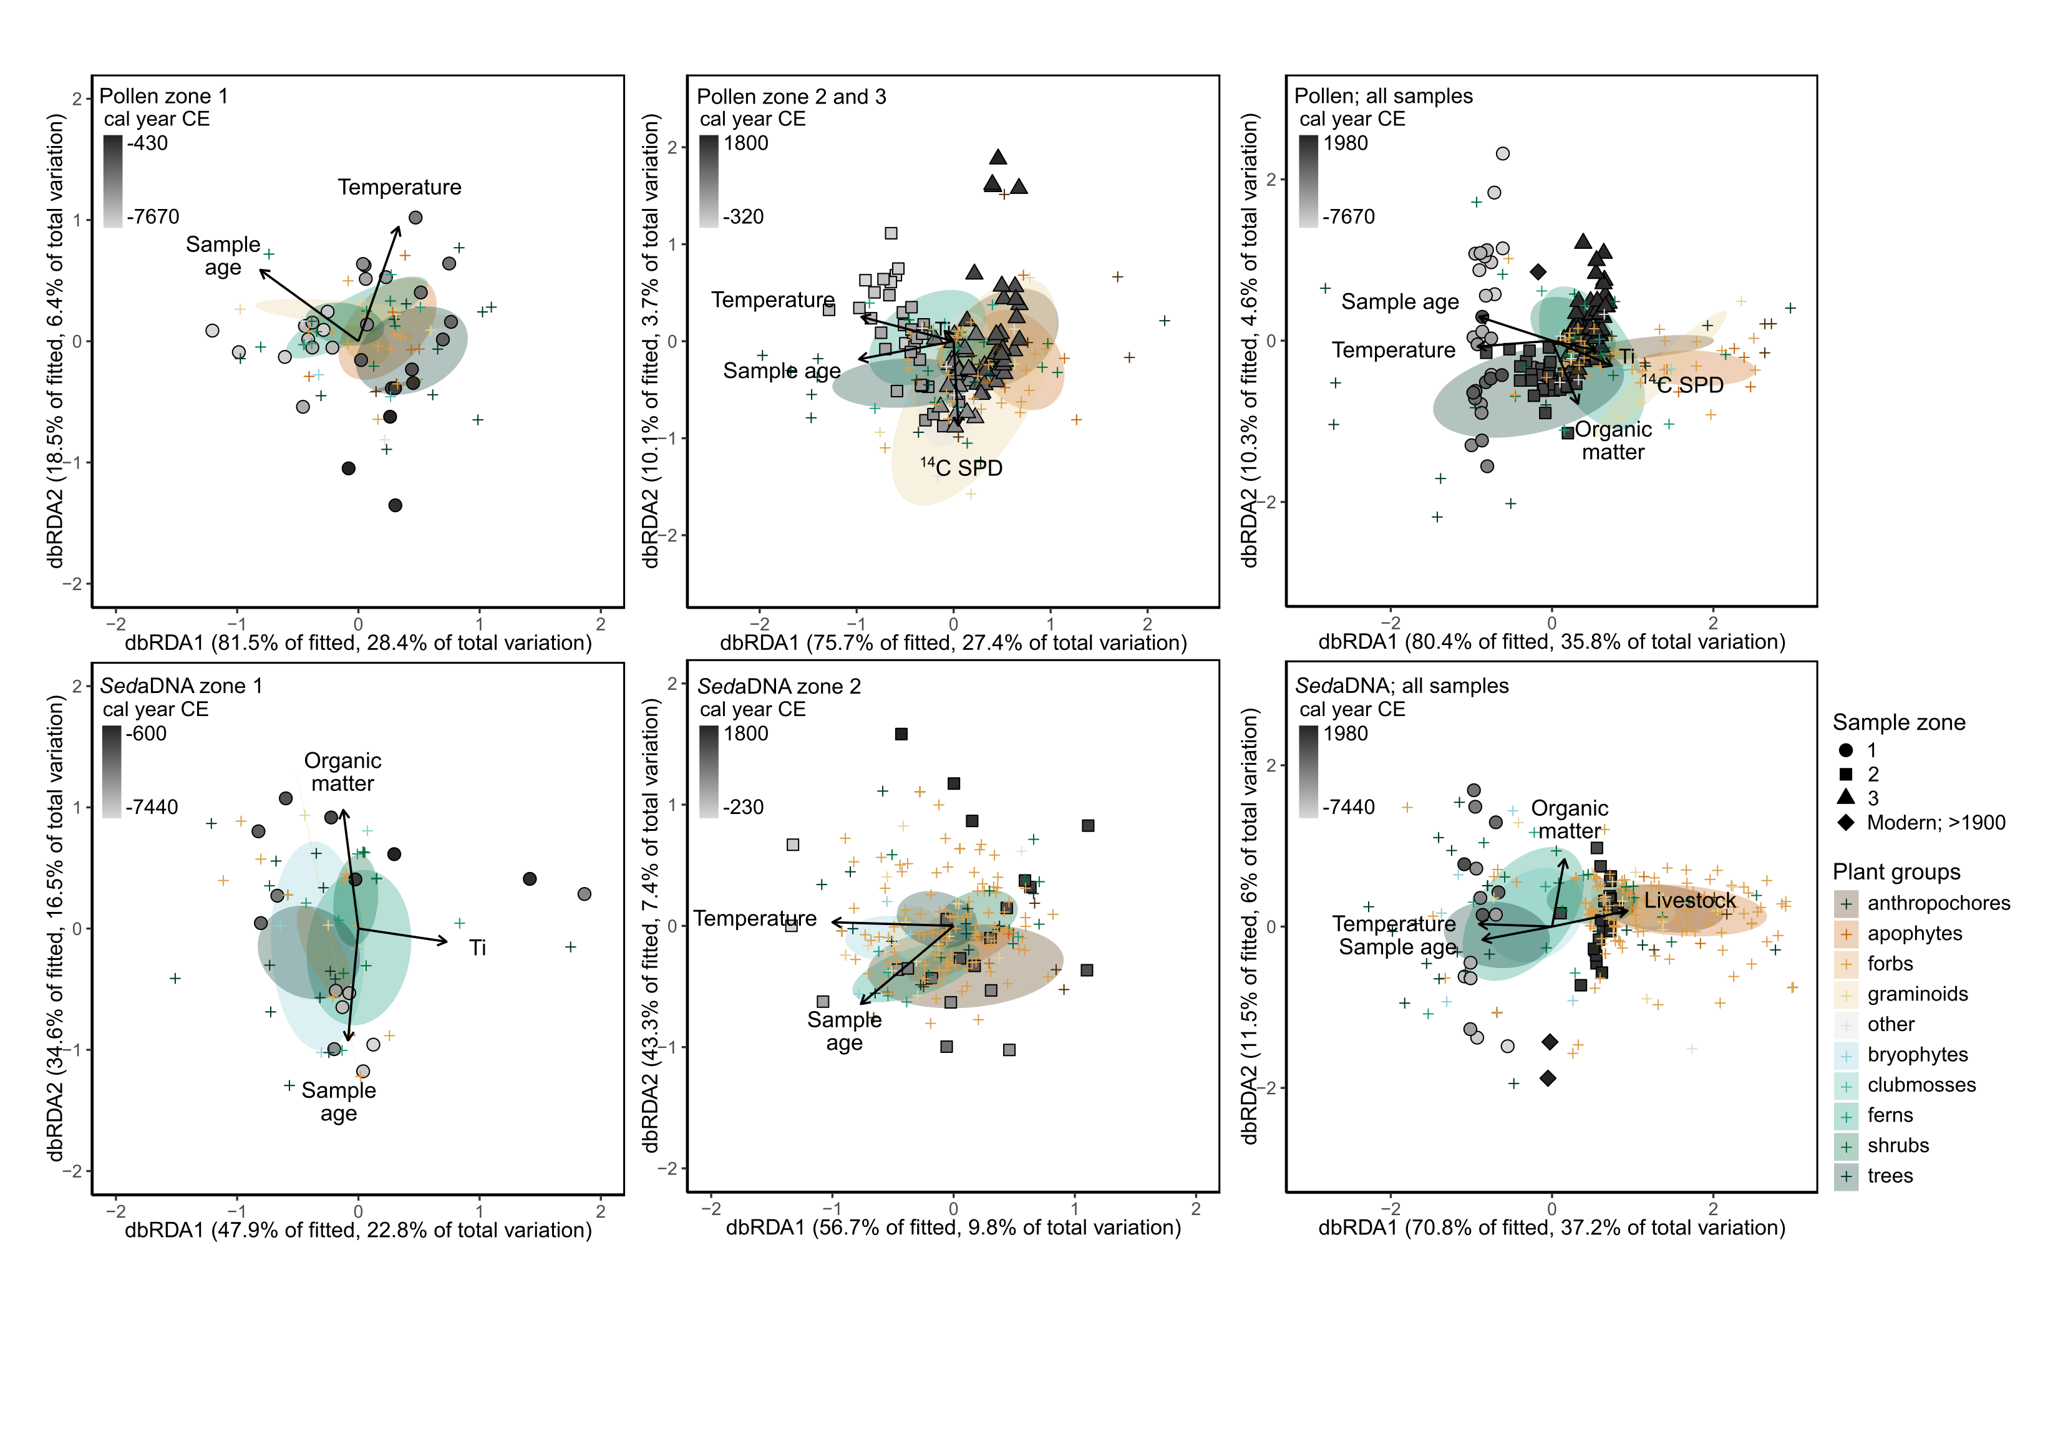

**Fig. A.11.1.** Pollen (top) and *sed*aDNA (bottom) dbRDA ordination sample scores (filled symbols) and plant taxa scores (plus symbols; coloured per plant group) of models including the sample age, illustrating close correlations between sample age and temperature especially when including all samples (right; see also Table A.11 and Appendix A.12). Ellipses indicate the standard error of the mean per plant group. Arrows indicate significant environmental terms. Environmental terms included in dbRDAs: temperature corresponds to the temperature anomaly data from Sejrup et al. (2016), organic matter corresponds to the Inc/Coh ratio determined by XRF analysis, Ti is measured by XRF analysis, livestock corresponds to presence/absence of livestock DNA, charcoal corresponds to the charcoal concentrations determined by palynological analysis, and 14C SPD corresponds to radiocarbon summed probability distributions, a proxy for palaeodemography.

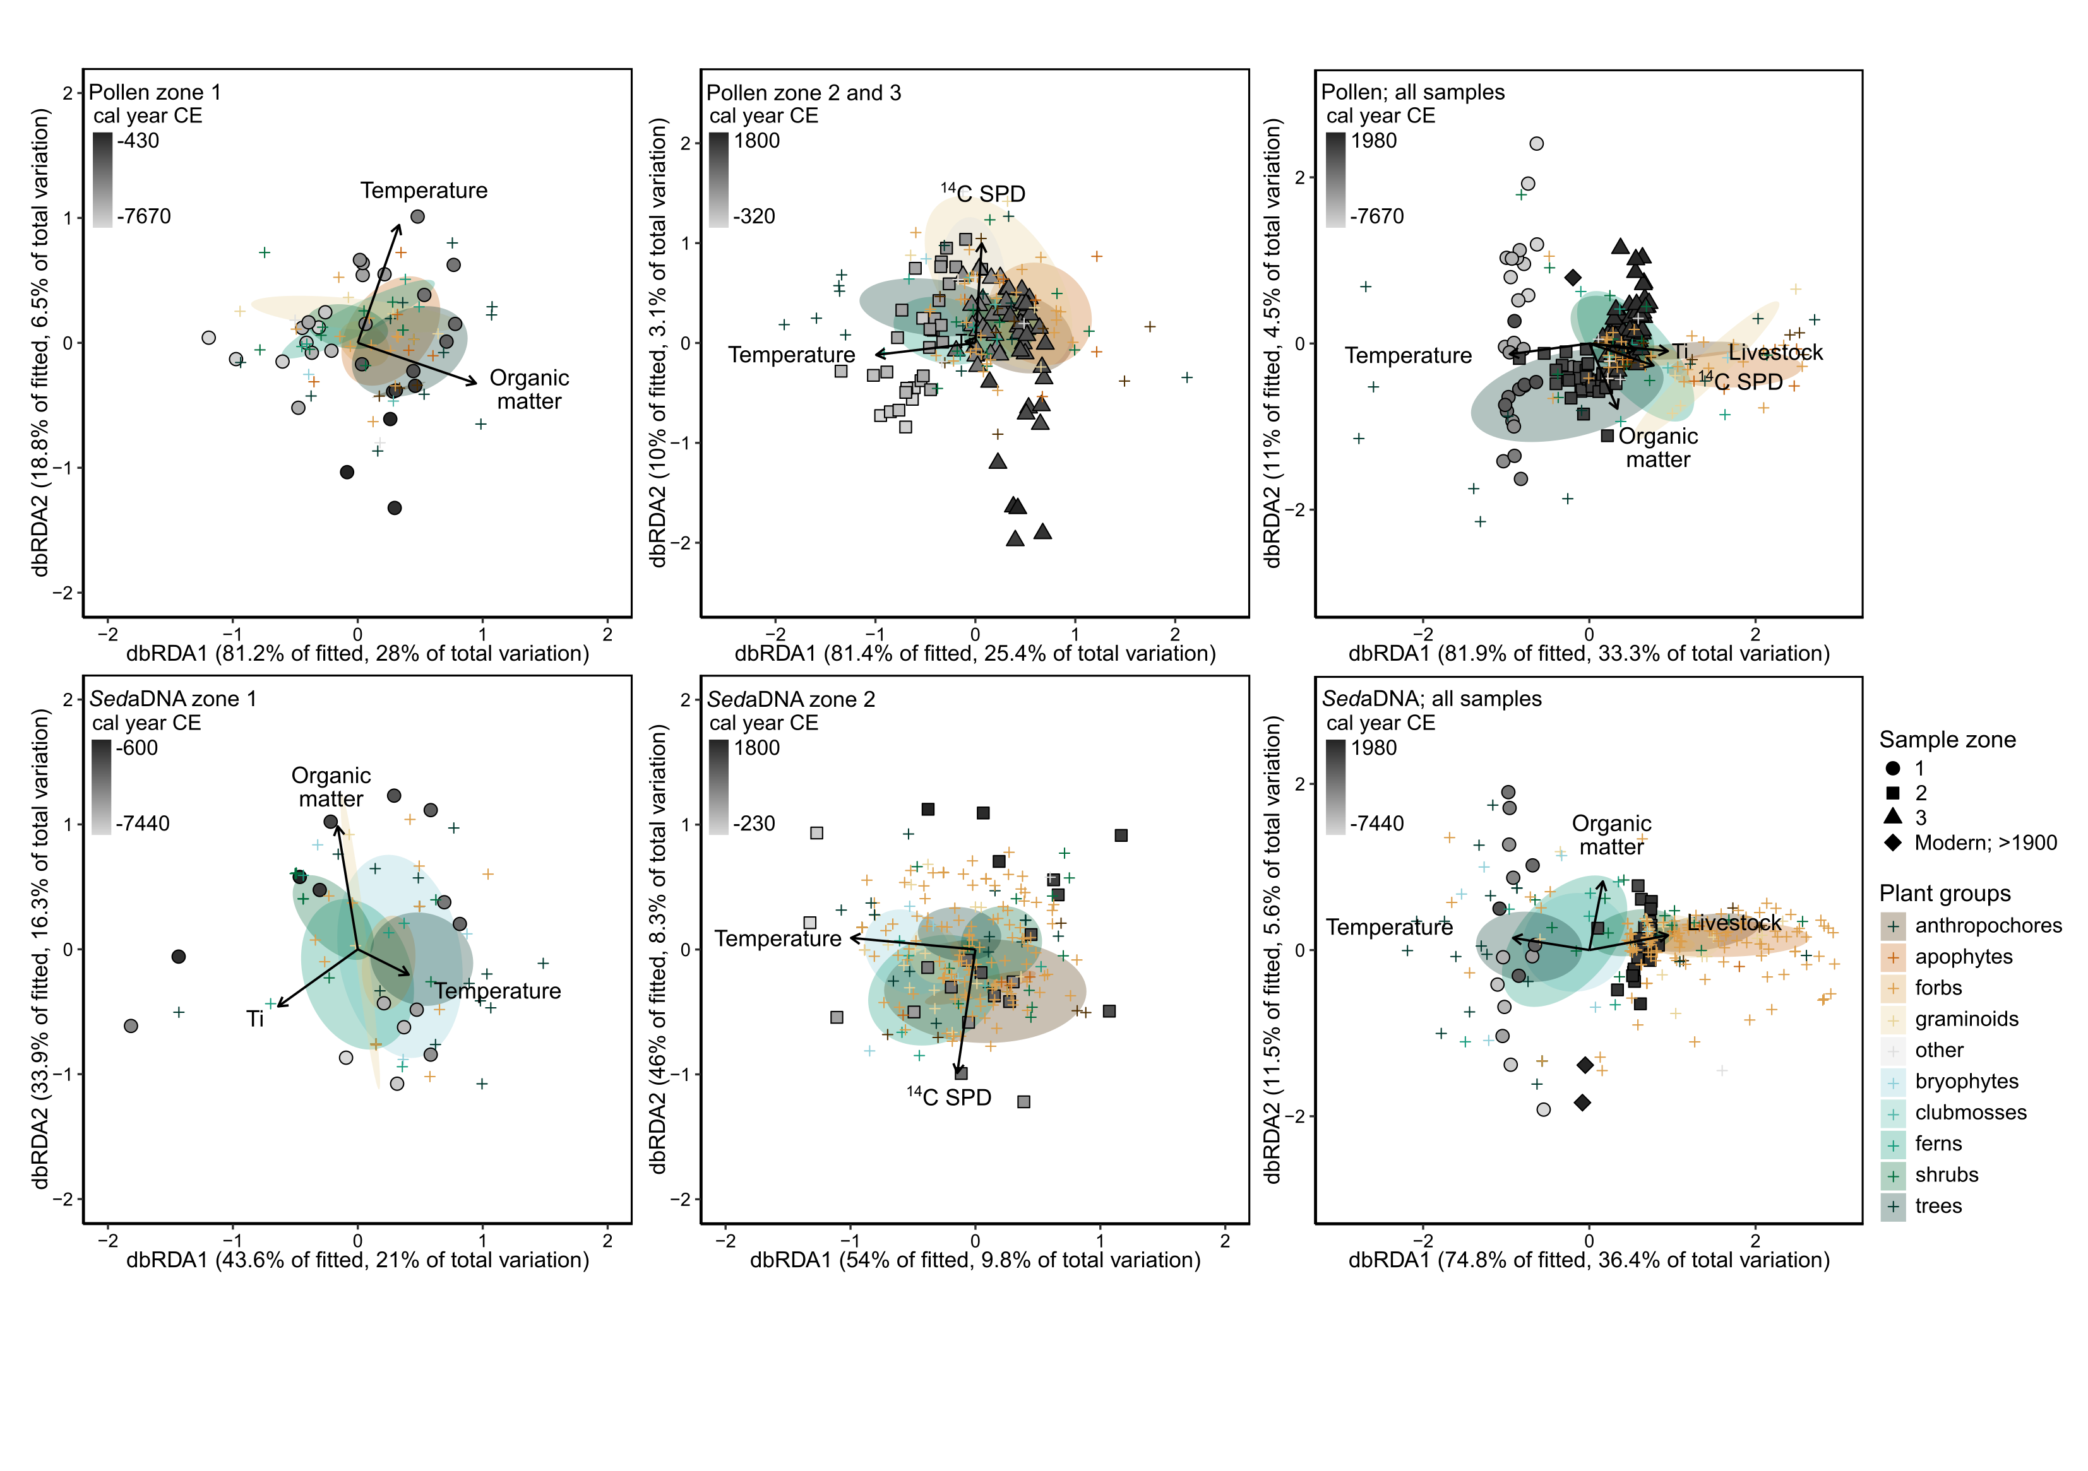

**Fig. A.11.2.** Pollen (top) and *sed*aDNA (bottom) dbRDA ordination sample scores (filled symbols) and plant taxa scores (plus symbols; coloured per plant group) of models excluding the sample age. Ellipses indicate the standard error of the mean per plant group. Arrows indicate significant environmental terms. Environmental terms included in dbRDAs: temperature corresponds to the temperature anomaly data from Sejrup et al. (2016), organic matter corresponds to the Inc/Coh ratio determined by XRF analysis, Ti is measured by XRF analysis, livestock corresponds to presence/absence of livestock DNA, charcoal corresponds to the charcoal concentrations determined by palynological analysis, and 14C SPD corresponds to radiocarbon summed probability distributions, a proxy for palaeodemography.

**Table. A.11.** Proportions of variance explained per environmental term of the total variance in plant assemblages for 12 automatic stepwise dbRDAs based on: samples from all zones combined, samples from after 300 cal BCE, and samples from before 300 cal BCE for *sed*aDNA and pollen datasets. DbRDAs were performed both including and excluding (indicated with a cross) sample age in cal BP. Other environmental terms included in dbRDAs: temperature corresponds to the temperature anomaly data from Sejrup et al. (2016), organic matter corresponds to the Inc/Coh ratio determined by XRF analysis, Ti is measured by XRF analysis, livestock corresponds to presence/absence of livestock DNA, charcoal corresponds to the charcoal concentrations determined by palynological analysis, and 14C SPD corresponds to radiocarbon summed probability distributions, a proxy for palaeodemography. Blank cells indicate that the environmental term was not included in the model as inclusion did not result in a better model (increased adjusted R2). Grey shading shows proportions of variance categories and significant values are indicated in bold; asterisks indicate significance with ‘***’ *p* ≤ 0.001, ‘**’ *p* ≤ 0.01 and ‘*’ *p* ≤ 0.05.

|  |  |  |  |  |  |  |  |  |  |
| --- | --- | --- | --- | --- | --- | --- | --- | --- | --- |
| **Samples used in dbRDA** | |  | Sample age  (cal. BP) | Temperature (Sejrup et al., 2016) | Organic matter  (Inc/Coh ratio) | Ti | Livestock | Charcoal | 14C SPD |
| All zones | *Sed*aDNA | | **0.040\*** | **0.034\*** | **0.055\*\*** | 0.026 | **0.085\*\*\*** |  |  |
|  |  | *P-value* | *0.028* | *0.048* | *0.007* | *0.090* | *0.001* |  |  |
|  |  |  | X | **0.060\*\*** | **0.055\*** | 0.029 | **0.070\*\*** |  |  |
|  |  | *P-value* | *0.006* | *0.014* | *0.092* | *0.005* |  |  |
|  | Pollen |  | **0.044\*\*\*** | **0.014\*** | **0.047\*\*\*** | **0.021\*\*** | 0.010 |  | **0.016\*** |
|  |  | *P-value* | *0.001* | *0.042* | *0.001* | *0.010* | *0.100* |  | *0.028* |
|  |  |  | X | **0.050\*\*\*** | **0.040\*\*\*** | **0.018\*** | **0.024\*\*** |  | **0.015\*** |
|  |  | *P-value* | *0.001* | *0.001* | *0.025* | *0.007* |  | *0.044* |
| > 300 cal BCE | *Sed*aDNA | | 0.074 | **0.084\*** |  |  |  |  |  |
|  | *P-value* | *0.078* | *0.033* |  |  |  |  |  |
|  |  | X | **0.098\*\*** |  |  |  |  | **0.083\*** |
|  | *P-value* | *0.008* |  |  |  |  | *0.030* |
| Pollen |  | **0.043\*\*\*** | **0.020\*** | **0.018\*** | **0.029\*\*** |  |  | **0.021\*** |
|  | *P-value* | *0.001* | *0.026* | *0.037* | *0.002* |  |  | *0.021* |
|  |  | X | **0.289\*\*\*** |  | **0.032\*\*** |  |  | **0.036\*\*\*** |
|  |  | *P-value* | *0.001* |  | *0.004* |  |  | *0.001* |
| < 300 cal BCE | *Sed*aDNA | | **0.153\*\*** |  | **0.150\*\*** | **0.165\*\*\*** |  |  |  |
|  | *P-value* | *0.003* |  | *0.002* | *0.001* |  |  |  |
|  |  | X | **0.157\*\*\*** | **0.163\*\*\*** | **0.197\*\*\*** |  |  |  |
|  | *P-value* | *0.001* | *0.001* | *0.001* |  |  |  |
| Pollen |  | **0.276\*\*\*** | **0.149\*\*\*** |  |  |  |  |  |
|  | *P-value* | *0.001* | *0.001* |  |  |  |  |  |
|  |  |  | X | **0.095\*\*** | **0.278\*\*\*** |  |  |  |  |
|  |  | *P-value* | *0.007* | *0.001* |  |  |  |  |
|  |  |  |  |  |  |  |  |  |  |

Conditional proportion of variance

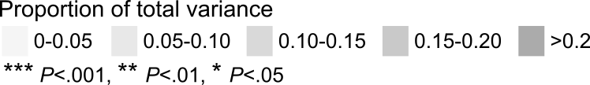

## A.12. Variation partitioning

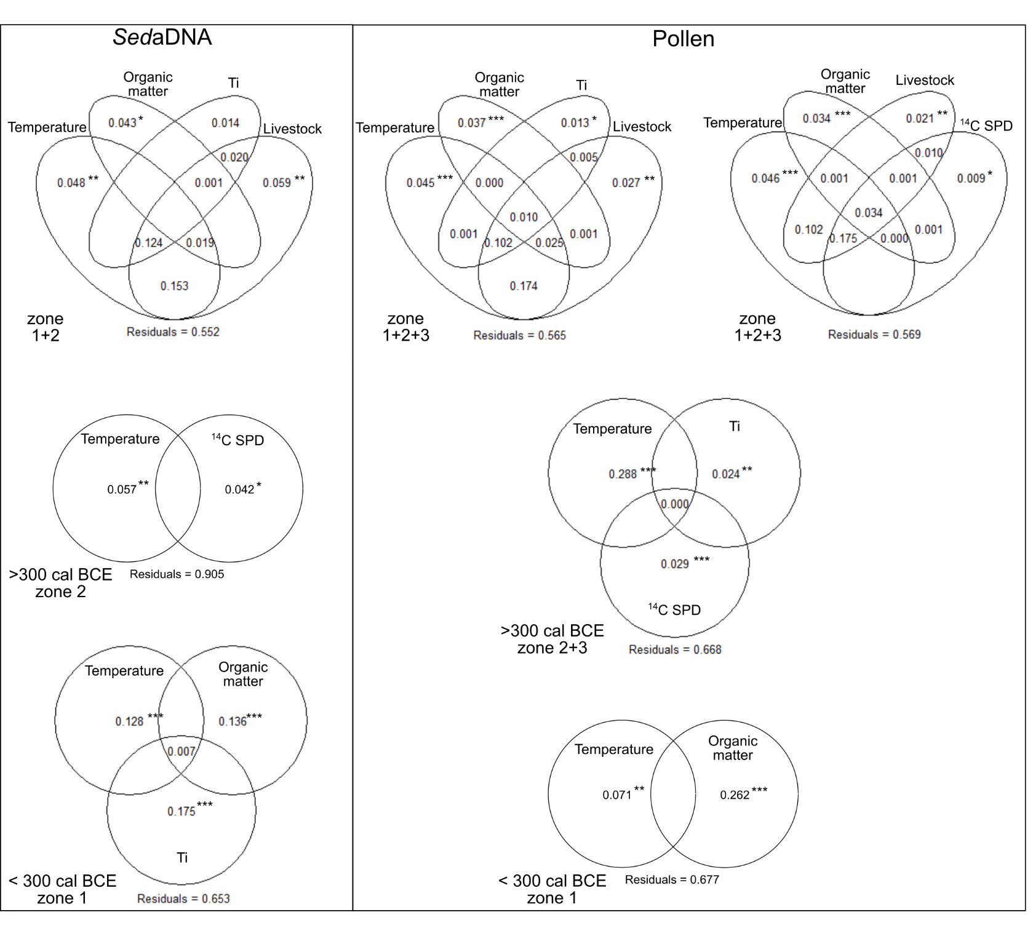

**Fig. A.12.** Partitioning of the proportions of variance explained per environmental term of the total variance in plant assemblages based on: samples from all zones combined, samples from after 300 cal BCE, and samples from before 300 cal BCE for *sed*aDNA (left) and pollen (right) datasets. Only environmental terms included in the automated stepwise dbRDAs were used in the variation partitioning (see Appendix A.11 for details). The number of included environmental terms for variation partitioning is limited to 4, therefore two separate variation partitioning analyses were performed for pollen samples from zone 1, 2 and 3 combined. Environmental terms included: temperature corresponds to the temperature anomaly data from Sejrup et al. (2016), organic matter corresponds to the Inc/Coh ratio determined by XRF analysis, Ti is measured by XRF analysis, livestock corresponds to presence/absence of livestock DNA, and 14C SPD corresponds to radiocarbon summed probability distributions, a proxy for palaeodemography. Values below 0 are not shown. Asterisks indicate significance with ‘***’ *p* ≤ 0.001, ‘**’ *p* ≤ 0.01 and ‘*’ *p* ≤ 0.05 based on dbRDA analysis (see Appendix A.11).

## A.13. Correlations between environmental terms

**Table A.13.1.** Spearman rank correlations between environmental terms at the time resolution of the pollen data (top-right; N=120) and the *sed*aDNA data (bottom-left; N=39) for the entire research period (ca. 7700 cal BCE-1975 cal CE). P-values were adjusted with the Bonferroni method and significant correlations are indicated in bold with grey shading.

|  |  |  |  |  |  |  |  |  |  |  |  |
| --- | --- | --- | --- | --- | --- | --- | --- | --- | --- | --- | --- |
|  |  | Sample age (cal. BP) | Organic matter  (Inc/Coh ratio) | Ti | Temperature (Sejrup et al., 2016) | Charcoal | 14C SPD | Livestock | Diversity  (HillN2) | NMDS1 | NMDS2 |
| All samples | Sample age  (cal BP) |  | -0.1 | **-0.39** | **0.93** | **-0.51** | **-0.5** | **-0.69** | **-0.63** | **-0.9** | 0.12 |
| *P.adj* |  | *1* | *0* | *0* | *0* | *0* | *0* | *0* | *0* | *1* |
| Organic matter  (Inc/Coh ratio) | -0.07 |  | -0.18 | -0.09 | 0.24 | 0.08 | 0.03 | 0.16 | 0.04 | **0.31** |
| *P.adj* | *1* |  | *1* | *1* | *0.42* | *1* | *1* | *1* | *1* | *0.04* |
| Ti | **-0.57** | -0.43 |  | **-0.32** | **0.54** | **0.47** | **0.54** | **0.48** | **0.36** | -0.02 |
| *P.adj* | *0.01* | *0.31* |  | *0.01* | *0* | *0* | *0* | *0* | *0* | *1* |
| Temperature (Sejrup et al., 2016) | **0.81** | -0.14 | -0.38 |  | **-0.56** | **-0.6** | **-0.74** | **-0.59** | **-0.92** | 0.12 |
| *P.adj* | *0* | *1* | *0.84* |  | *0* | *0* | *0* | *0* | *0* | *1* |
| Charcoal | **-0.57** | 0.21 | 0.49 | **-0.68** |  | **0.57** | **0.65** | **0.55** | **0.57** | 0.12 |
| *P.adj* | *0.01* | *1* | *0.07* | *0* |  | *0* | *0* | *0* | *0* | *1* |
| 14C SPD | -0.29 | 0.31 | 0.24 | **-0.59** | **0.75** |  | **0.71** | **0.58** | **0.55** | 0 |
| *P.adj* | *1* | *1* | *1* | *0* | *0* |  | *0* | *0* | *0* | *1* |
| Livestock | **-0.59** | 0.03 | **0.59** | **-0.77** | **0.8** | **0.72** |  | **0.63** | **0.7** | 0.03 |
| *P.adj* | *0* | *1* | *0* | *0* | *0* | *0* |  | *0* | *0* | *1* |
| Diversity (HillN2) | **-0.61** | 0.04 | **0.56** | **-0.73** | **0.8** | **0.59** | **0.84** |  | **0.61** | -0.3 |
| *P.adj* | *0* | *1* | *0.01* | *0* | *0* | *0* | *0* |  | *0* | *0.07* |
| NMDS1 | **-0.62** | -0.05 | **0.6** | **-0.76** | **0.8** | **0.58** | **0.84** | **0.95** |  | -0.03 |
| *P.adj* | *0* | *1* | *0* | *0* | *0* | *0* | *0* | *0* |  | *1* |
| NMDS2 | -0.47 | -0.08 | 0.27 | -0.47 | 0.06 | 0.12 | 0.16 | 0.02 | 0.04 |  |
| *P.adj* | *0.1* | *1* | *1* | *0.13* | *1* | *1* | *1* | *1* | *1* |  |

**Table A.13.2.** Spearman rank correlations between environmental terms at the time resolution of the pollen data (top-right; N=90) and the *sed*aDNA data (bottom-left; N=22) for zone 2 & 3 (ca. 300 cal BCE-1800 cal CE). P-values were adjusted with the Bonferroni method and significant correlations are indicated in bold with grey shading.

|  |  |  |  |  |  |  |  |  |  |  |  |
| --- | --- | --- | --- | --- | --- | --- | --- | --- | --- | --- | --- |
|  |  | Sample age (cal. BP) | Organic matter  (Inc/Coh ratio) | Ti | Temperature (Sejrup et al., 2016) | Charcoal | 14C SPD | Livestock | Diversity  (HillN2) | NMDS1 | NMDS2 |
| Zone 2 & 3 (ca. 300 cal BCE – 450 cal CE) | Sample age  (cal BP) |  | 0.05 | 0.25 | **0.93** | 0.03 | 0 | -0.18 | **-0.37** | **-0.9** | 0.33 |
| *P.adj* |  | *1* | *0.89* | *0* | *1* | *1* | *1* | *0.02* | *0* | *0.06* |
| Organic matter  (Inc/Coh ratio) | 0.09 |  | -0.31 | -0.03 | 0.27 | -0.14 | -0.23 | -0.03 | -0.03 | 0.01 |
| *P.adj* | *1* |  | *0.13* | *1* | *0.48* | *1* | *1* | *1* | *1* | *1* |
| Ti | 0.16 | -0.53 |  | **0.34** | 0.21 | 0.07 | -0.09 | 0.14 | -0.24 | 0.01 |
| *P.adj* | *1* | *0.47* |  | *0.04* | *1* | *1* | *1* | *1* | *1* | *1* |
| Temperature (Sejrup et al., 2016) | **0.69** | -0.33 | 0.6 |  | -0.04 | -0.15 | -0.18 | -0.29 | -0.87 | 0.26 |
| *P.adj* | *0.02* | *1* | *0.14* |  | *1* | *1* | *1* | *0.25* | *0* | *0.57* |
| Charcoal | 0.42 | 0.33 | -0.03 | 0.18 |  | 0.08 | -0.04 | 0.13 | 0.07 | 0.05 |
| *P.adj* | *1* | *1* | *1* | *1* |  | *1* | *1* | *1* | *1* | *1* |
| 14C SPD | 0.61 | 0.16 | -0.02 | 0.2 | 0.43 |  | 0.19 | 0.24 | 0.08 | -0.15 |
| *P.adj* | *0.12* | *1* | *1* | *1* | *1* |  | *1* | *1* | *1* | *1* |
| Livestock | 0.26 | -0.12 | 0.36 | 0.26 | 0.02 | 0.22 |  | 0.15 | 0.15 | -0.1 |
| *P.adj* | *1* | *1* | *1* | *1* | *1* | *1* |  | *1* | *1* | *1* |
| Diversity (HillN2) | 0.08 | 0.11 | 0.28 | 0.11 | 0.31 | 0.15 | 0.15 |  | 0.31 | -0.77 |
| *P.adj* | *1* | *1* | *1* | *1* | *1* | *1* | *1* |  | *0.13* | *0* |
| NMDS1 | -0.03 | 0.23 | 0.3 | -0.09 | 0.31 | 0.17 | 0.15 | **0.85** |  | -0.16 |
| *P.adj* | *1* | *1* | *1* | *1* | *1* | *1* | *1* | *0* |  | *1* |
| NMDS2 | -0.51 | -0.07 | -0.33 | -0.59 | -0.34 | -0.23 | -0.29 | **-0.75** | -0.5 |  |
| *P.adj* | *0.74* | *1* | *1* | *0.17* | *1* | *1* | *1* | *0* | *0.86* |  |

**Table A.13.3.** Spearman rank correlations between environmental terms at the time resolution of the pollen data (top-right; N=29) and the *sed*aDNA data (bottom-left; N=15) for zone 1 (ca. 8000-300 cal BCE). P-values were adjusted with the Bonferroni method and significant correlations are indicated in bold with grey shading.

|  |  |  |  |  |  |  |  |  |  |  |  |
| --- | --- | --- | --- | --- | --- | --- | --- | --- | --- | --- | --- |
|  |  | Sample age (cal. BP) | Organic matter  (Inc/Coh ratio) | Ti | Temperature (Sejrup et al., 2016) | Charcoal | 14C SPD | Livestock | Diversity  (HillN2) | NMDS1 | NMDS2 |
| Zone 1 (ca. 8000 - 300 cal BCE) | Sample age  (cal BP) |  | **-0.95** | 0.39 | 0.05 | -0.35 | **-0.7** | NA | -0.52 | 0.25 | **-0.7** |
| *P.adj* |  | *0* | *1* | *1* | *1* | *0* |  | *0.13* | *1* | *0* |
| Organic matter  (Inc/Coh ratio) | **-0.95** |  | -0.46 | 0.01 | 0.3 | **0.6** | NA | 0.55 | -0.27 | **0.71** |
| *P.adj* | *0* |  | *0.44* | *1* | *1* | *0.02* |  | *0.07* | *1* | *0* |
| Ti | 0.62 | -0.69 |  | 0.17 | -0.21 | -0.23 | NA | -0.21 | -0.1 | -0.39 |
| *P.adj* | *0.46* | *0.17* |  | *1* | *1* | *1* |  | *1* | *1* | *1* |
| Temperature (Sejrup et al., 2016) | 0.37 | -0.3 | 0.43 |  | 0.35 | -0.14 | NA | 0.53 | -0.25 | 0.38 |
| *P.adj* | *1* | *1* | *1* |  | *1* | *1* |  | *0.12* | *1* | *1* |
| Charcoal | -0.36 | 0.47 | -0.17 | 0.4 |  | 0.1 | NA | 0.34 | -0.11 | 0.44 |
| *P.adj* | *1* | *1* | *1* | *1* |  | *1* |  | *1* | *1* | *0.6* |
| 14C SPD | -0.69 | 0.64 | -0.35 | -0.27 | 0.06 |  | NA | 0.31 | 0.14 | 0.44 |
| *P.adj* | *0.16* | *0.37* | *1* | *1* | *1* |  |  | *1* | *1* | *0.58* |
| Livestock | NA | NA | NA | NA | NA | NA |  | NA | NA | NA |
| *P.adj* |  |  |  |  |  |  |  |  |  |  |
| Diversity (HillN2) | 0.19 | -0.11 | -0.12 | 0.03 | 0.01 | -0.52 | NA |  | -0.19 | **0.92** |
| *P.adj* | *1* | *1* | *1* | *1* | *1* | *1* |  |  | *1* | *0* |
| NMDS1 | 0.7 | -0.66 | 0.13 | 0.25 | -0.09 | **-0.77** | NA | 0.65 |  | -0.15 |
| *P.adj* | *0.13* | *0.25* | *1* | *1* | *1* | *0.03* |  | *0.3* |  | *1* |
| NMDS2 | -0.07 | -0.02 | 0.16 | -0.47 | -0.57 | 0.26 | NA | -0.26 | -0.46 |  |
| *P.adj* | *1* | *1* | *1* | *1* | *0.9* | *1* | *NA* | *1* | *1* |  |

## References

Blaauw, M., & Christen, J. A. (2011). Flexible paleoclimate age-depth models using an autoregressive gamma process. *Bayesian analysis*, *6*(3), 457-474.

Boyer, F., Mercier, C., Bonin, A., Le Bras, Y., Taberlet, P., & Coissac, E. (2016). obitools: A unix‐inspired software package for DNA metabarcoding. *Molecular ecology resources*, *16*(1), 176-182. https://doi.org/10.1111/1755-0998.12428

Grimm, E. C. (1987). CONISS: a FORTRAN 77 program for stratigraphically constrained cluster analysis by the method of incremental sum of squares. *Computers & geosciences*, *13*(1), 13-35.

Juggins, S. (2020). *rioja: Analysis of Quaternary Science Data.* R package version 0.9-26, https://cran.r-project.org/package=rioja.

Kaufman, D., McKay, N., Routson, C., Erb, M., Dätwyler, C., Sommer, P. S., ... & Davis, B. (2020). Holocene global mean surface temperature, a multi-method reconstruction approach. *Scientific data*, *7*(1), 1-13. https://doi.org/10.1038/s41597-020-0530-7

Kotov, S., & Paelike, H. (2018, December). QAnalySeries-a cross-platform time series tuning and analysis tool. In *AGU Fall Meeting Abstracts* (Vol. 2018, pp. PP53D-1230).

Oksanen, J., Blanchet, F.G., Friendly, M., Kindt, R., Legendre, P., McGlinn, D., Minchin, P.R., O’Hara, R.B., Simpson, G.L., Solymos, P., Stevens, M.H.H., Szoecs, E. & Wagner, H. (2020). *vegan: Community Ecology Package.* R package version 2.5-7. https://CRAN.R-project.org/package=vegan

R Core Team (2020). R: A language and environment for statistical computing (manual). Vienna, Austria.

Reimer, P. J., Austin, W. E., Bard, E., Bayliss, A., Blackwell, P. G., Ramsey, C. B., ... & Talamo, S. (2020). The IntCal20 Northern Hemisphere radiocarbon age calibration curve (0–55 cal kBP). *Radiocarbon*, *62*(4), 725-757.

Sejrup, H. P., Seppä, H., McKay, N. P., Kaufman, D. S., Geirsdóttir, Á., de Vernal, A., ... & Andrews, J. T. (2016). North Atlantic-Fennoscandian Holocene climate trends and mechanisms. *Quaternary Science Reviews*, *147*, 365-378.

Simpson, G. L. (2018). Modelling palaeoecological time series using generalised additive models. *Frontiers in Ecology and Evolution*, *6*, 149.

Wood, S. (2018). Mixed GAM computation vehicle with GCV/AIC/REML smoothness estimation and GAMMs by REML/PQL. *R package version*, 1-8.